**Approving Staff Time - Computer**

From the Inside Roanoke homepage (www.roanoke.com/inside), select “Self Service”. (You may also approve time from Ellucian Go on your mobile device. Those instructions are found in another document.)



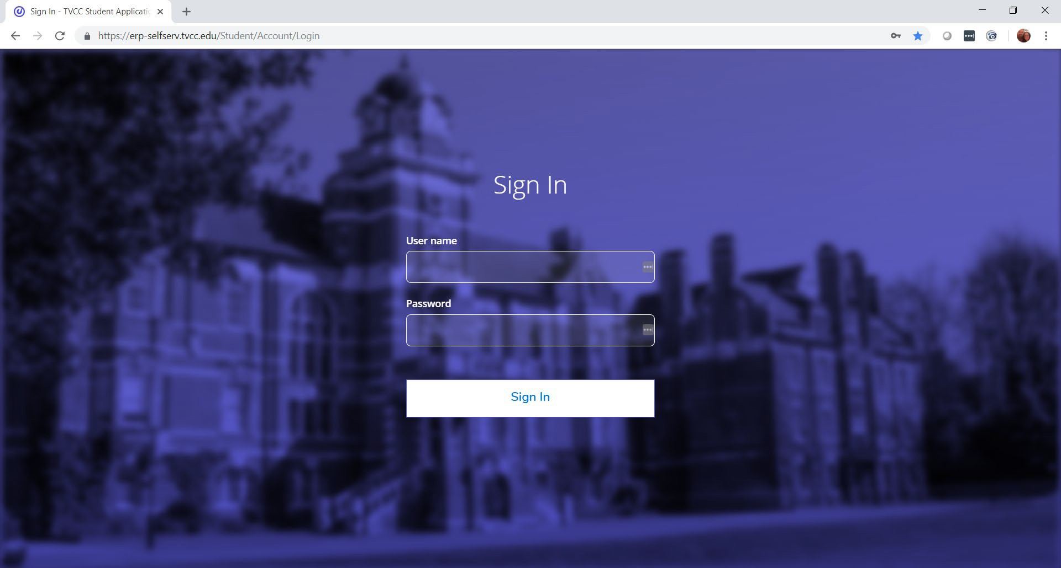If asked, log in with the same User Name and Password that you use for other campus systems.

To access the time approval screen in ESS, click on “Time Approval”

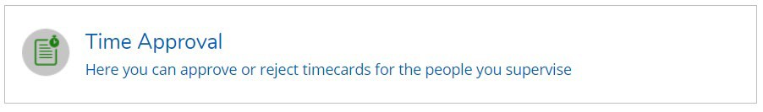

In the Time Approval area of ESS, you will be able to view, approve, reject, make comments and update your employee’s time. There are multiple ways to do these functions. Any time you approve, reject, make a change, or unapprove a timecard, the system will send an email to your employee that you have done so.

A few general tips about time approval:

* If you are editing time, please note that supervisor screens do NOT save automatically, unlike employee time entry screens. You must SAVE your changes as you go along.
* Be mindful of which week you are approving time for as more than one pay period may be open.
* If you have both students and staff, be mindful of the person you have picked for approval.
* Employees should be recording their time daily, and submitting their time to you on a weekly basis by 10 a.m. each Monday. You are encouraged to approve each week as it is submitted.
* All timecards for bi-weekly staff must be approved by 4:30 p.m. Monday following the end of the pay period.
* Terminology: “Reject” is used before you approve a timecard to send it back to the employee for changes.
* Terminology: “Unapprove” is used after you have approved the timecard and realize that corrections are needed. “Unapprove” does not send the timecard back to the employee; it reopens it up for you to make changes, or to then reject it to send it back to the employee.

All of the employees that you are a time approver for will show up in one list. Notice this list below has a mix of bi-weekly staff and student employees. The tabs differentiate student from staff payrolls.

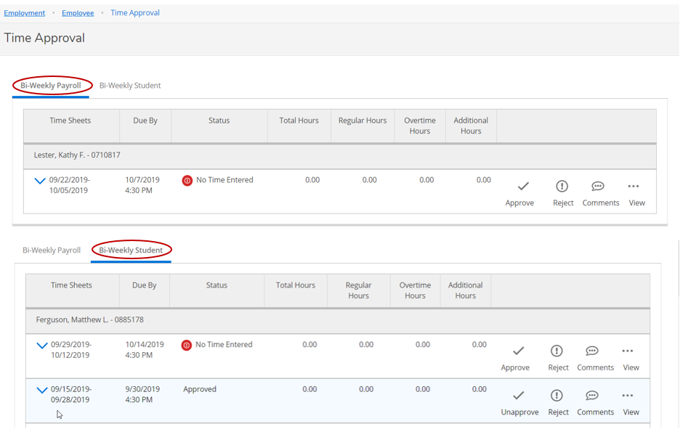

Supervisors have the option to approve, reject, add comments or view. You have several ways to do all of these. Here is where you do it from the main screen.

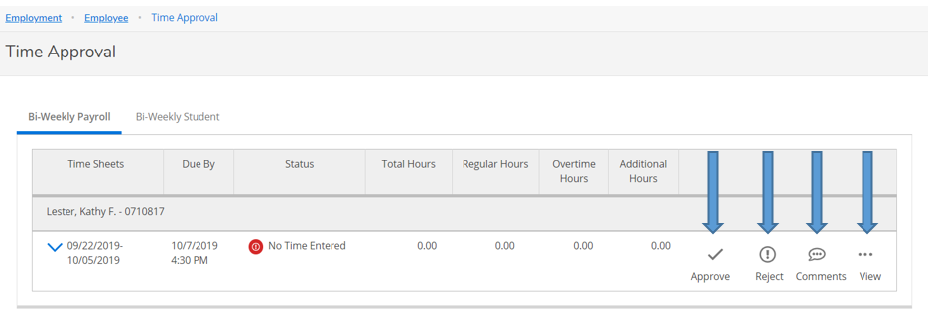

You can click on “view” to see the timecard detail. *It is highly recommended you do this before approving timecards.*

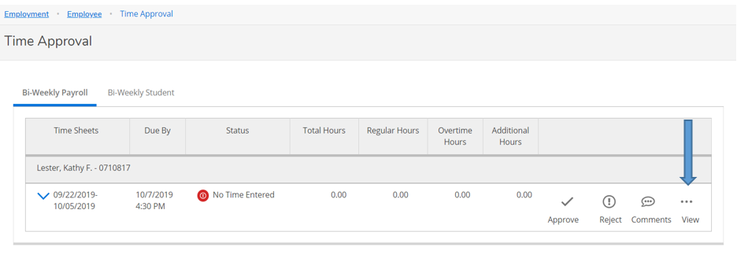

Once you’ve expanded the timecard, you can edit time, make comments, reject, and approve from this screen.

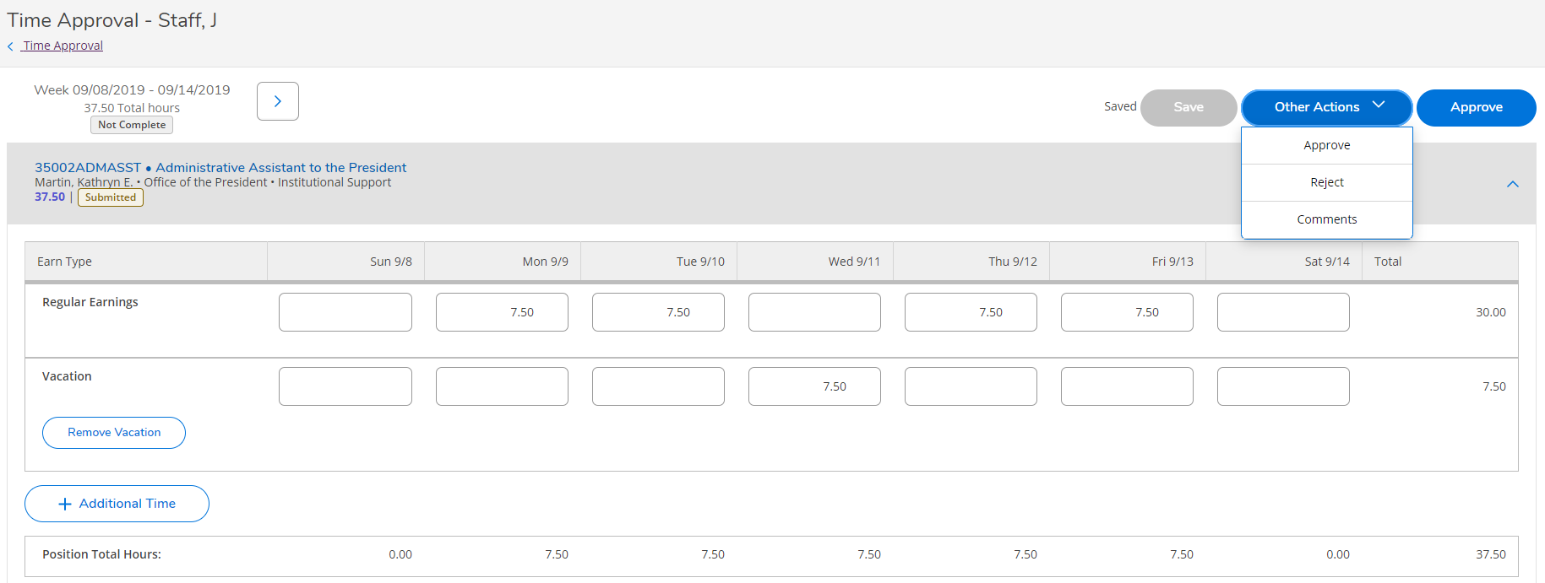

If you wish to add a comment, you must do it BEFORE you approve the timecard. If you forget, you will need to unapprove the timecard, make the comment and approve again. (Note: Your employee will get an e-mail when you unapprove the timecard, and again when you approve it.)

If your employee forgot to add leave to their timecard, you can add it for them or reject the timecard, sending it back for them to edit.

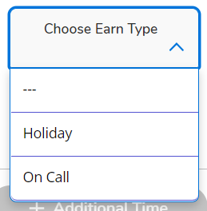If you would like to add time, enter the correct number of hours worked per day or click on +ADDITIONAL TIME choose the description that matches the time you need to enter for the employee. Key in the hours on the date the leave was used.

After you add the additional time, if you need to remove it you can click on REMOVE.

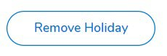

Once you have approved the timecard, green “Approved” boxes will appear and you are done with the employee.

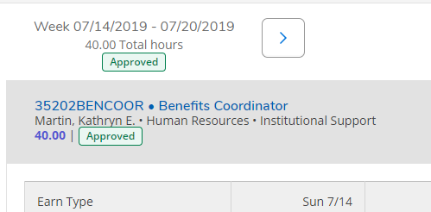

## Set up a Timecard Proxy Approver

To access the employee proxy area in ESS, click on “Employee Proxy”.

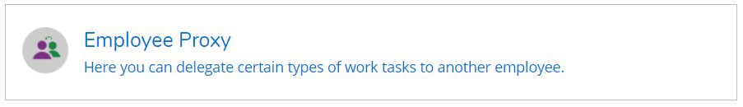

Click + ADD TIME APPROVAL PROXY

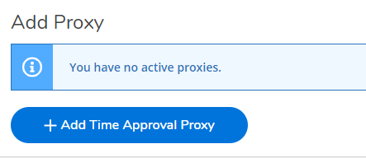

Enter the name of the person’s first and last name that you would like to approve your timecards and select their name from the list that pops up. Once selected click ADD PROXY. The system is not date sensitive. Once you set up a proxy, it goes into effect immediately and stays on until you remove it. It is not possible to proxy only a few of your employees; proxies effect everyone that reports to you.

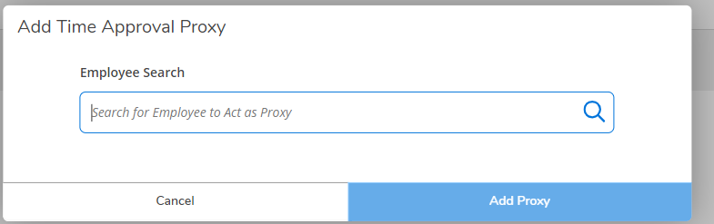

When you are finished, it will look like this. Click the red circled X to remove a proxy.

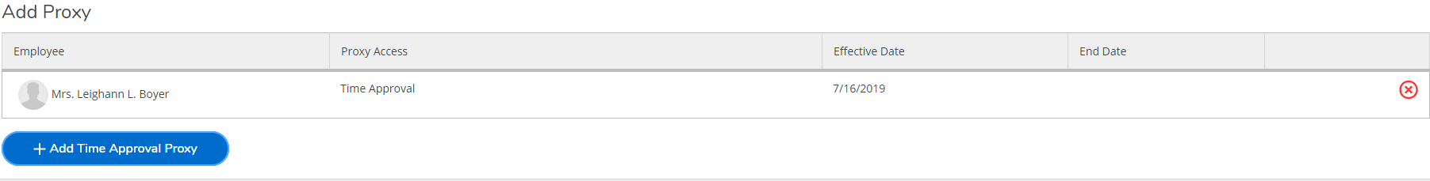

If you are the proxy for someone else, this is the screen you will see. You can toggle back and forth between your own timecards and the person you are filling in for.

