

Employee HR and Payroll Self Service (ESS)

Training Manual

2019



**Introduction to Employee Self-Service (ESS)**

Employee Self-Service is a web-based portal that provides you with visibility to salary and benefit information contained within the Ellucian Colleague modules. The ability to view human resource and payroll data provides an excellent opportunity for you to ensure that the information is correct and kept up to date. The data visible to you includes current and past earnings statements (pay check advice), current and past W-2’s, direct deposit information, leave balances, and more. Additionally, if you are a non-exempt employee, this is where you go to enter your time and where supervisors go to approve time for payment.

One of the major advantages of this system is that the data is real-time data. In other words, when you view your information, the system pulls the most current information directly from the HR/Payroll system. If any of the information that you view within ESS is incorrect or you encounter questions, please contact the HR or Payroll office immediately.

The college uses a single sign on to access this information. The same login and password that connects you to your computer will also give you access to ESS.

Table of Contents

Log In and Basic Layout 4

Managing Your User Profile 6

Accessing Employee Features within ESS 7

Employee Tax Information – W2’s 8

Employee Banking Information 9

Employee Earning Statements 14

Employee Leave Balances 15

Time History for Employee 16

Time Entry and Approval 17

Employee Time Entry 17

Supervisor Time Approval 22

Set up a Timecard Proxy Approver 26

Time History for Supervisor 28

Logging Off 29

Help and Support 29

# Log In and Basic Layout

From the Inside Roanoke homepage (www.roanoke.com/inside), select “Self Service”

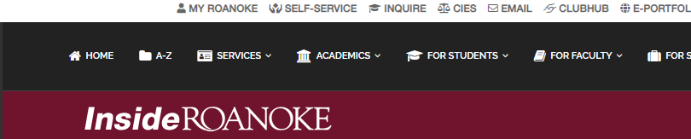

If asked, log in with the same User Name and Password that you use for other campus systems.

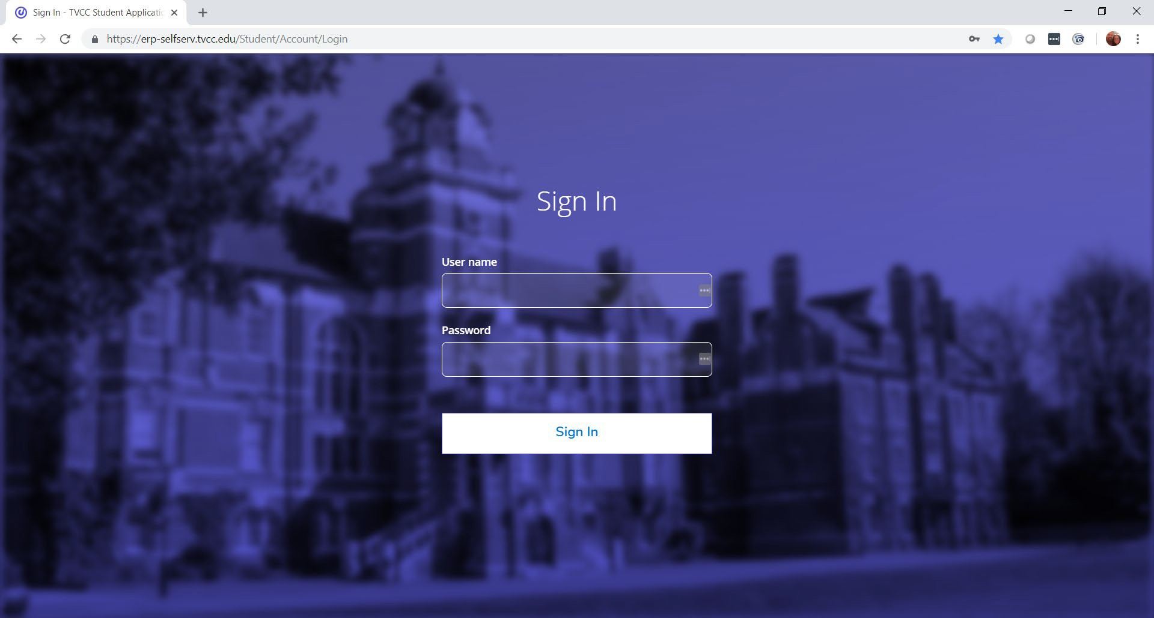

This is the explanation of icons that appear along the left hand side once you are logged in. You will only see the icons authorized for your position.

Click on this to expand the icons column. Click on it again will shrink the column.

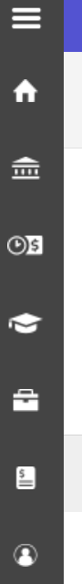

Click on this to display the home page

Click on this to display the Finance information menu

Click on this to display the Employment menu

Click on this to display the Academic menu

Click on this to display the Daily Work Menu

Click on this to display Vendor information

Click on this to display the User Options Menu

# Managing Your User Profile

To access your user profile, click on your name in the upper right and then select “User Profile”. It’s very important that you keep the information in your User Profile current. While you can view your address and phone number, you can NOT update these items from here; only your emergency contact information can be edited. To change your address or phone number, please contact Human Resources.

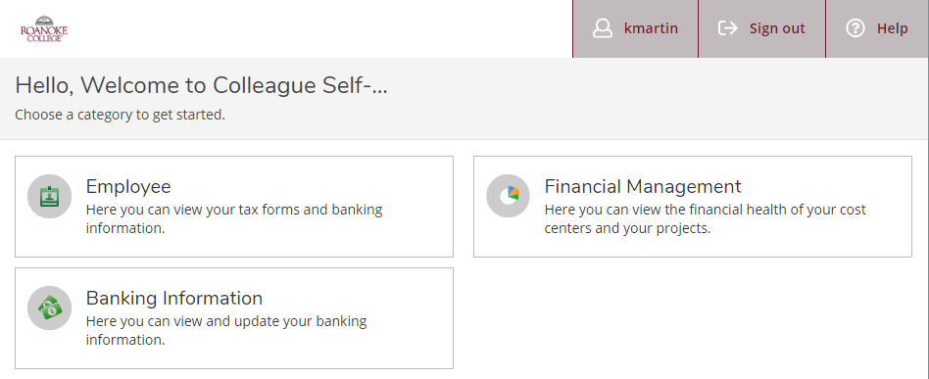You may change your Emergency Information. It is also where you can enter any health conditions in case of an emergency. This information is stored in the HR module of Colleague and is only accessible by Human Resources and Campus Safety.

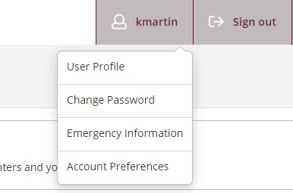

# Accessing Employee Features within ESS

Click on the tab labeled “Employee”.



This is where you will find any and all information related to Taxes, Time Entry, Earning Statements, Leave Balances, Banking Information, Time Approval and Employee Proxy.

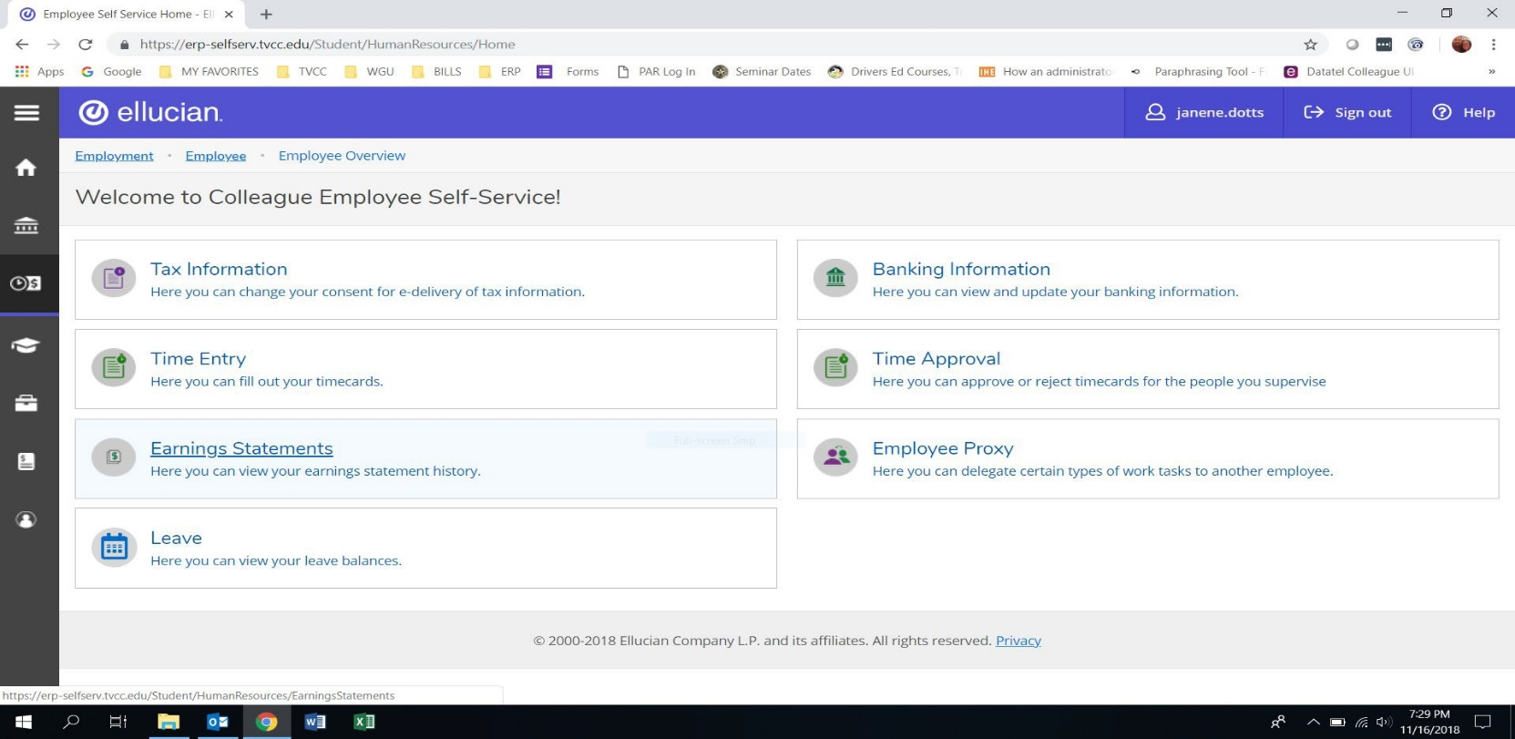

## Employee Tax Information – W2’s

To view your Tax information click on the “Tax Information” box.

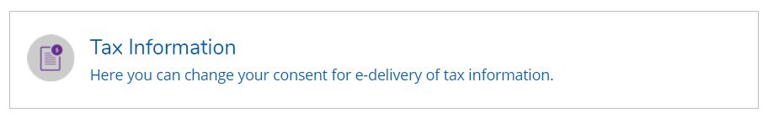

In this area you can set your preference for receiving your W-2. If you wish to receive them electronically then you can choose:

* Receive my W-2 only in electronic format or
* Withhold my consent and get your W-2 on paper.

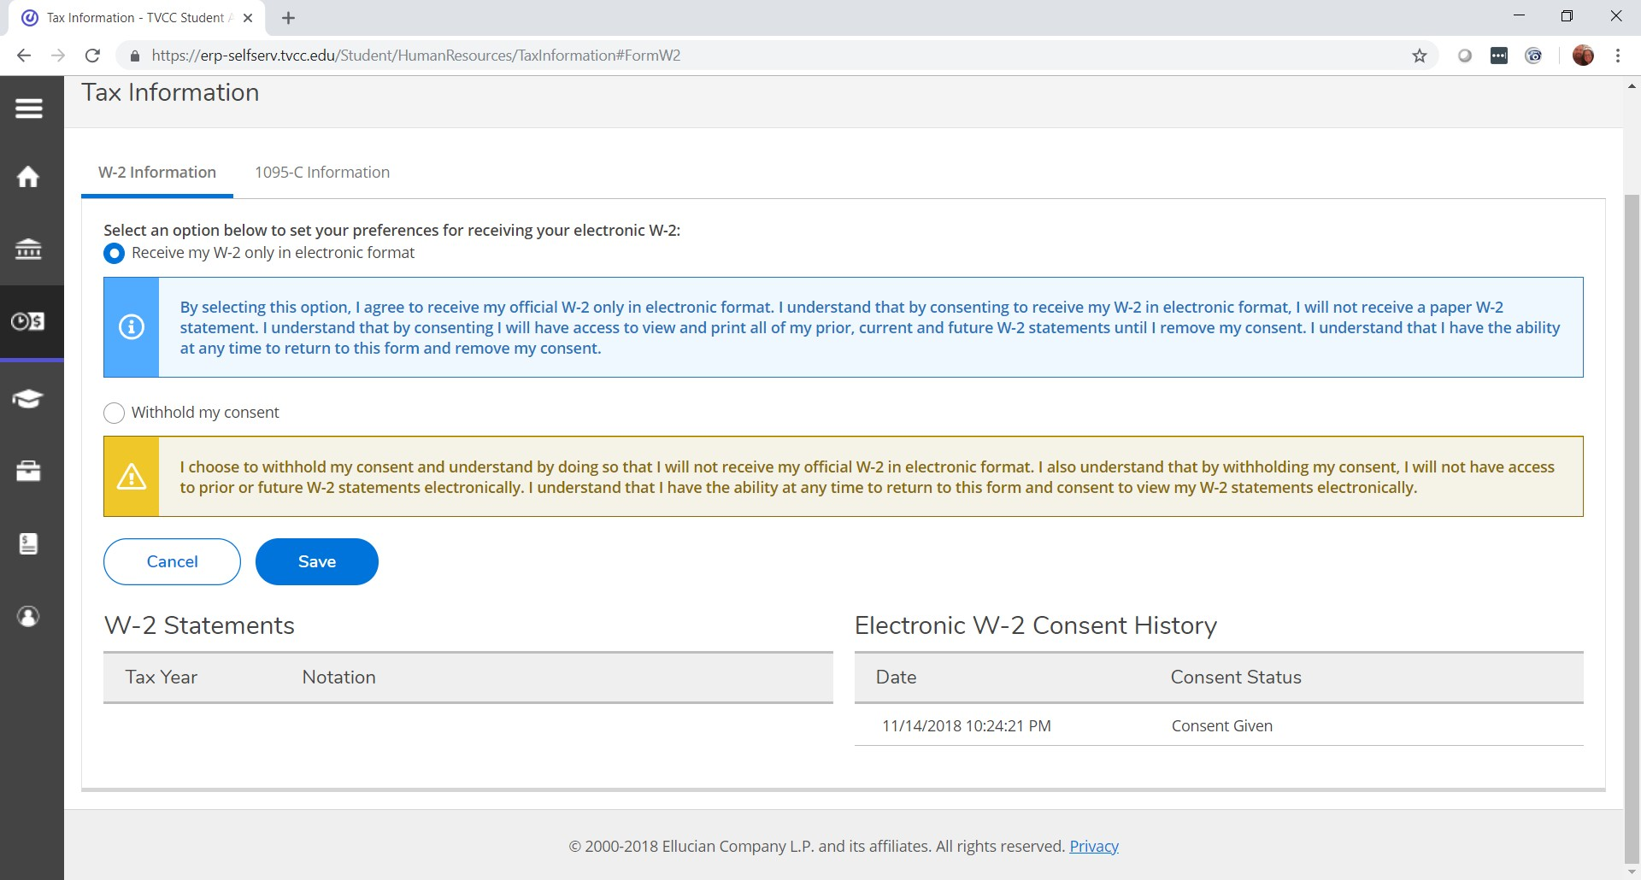

1

2

## Employee Banking Information

To view your banking information click on the “Banking Information” box.

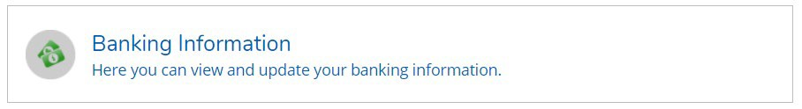

Please select “View All” to view your current banking information. Notice you can view both your payroll direct deposit accounts and direct deposit for checks processed through Accounts Payable (Refunds, Reimbursements & Payments).

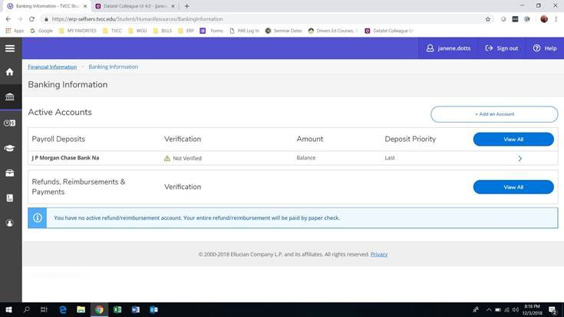

To make changes to your account, click the “+ add account” button.

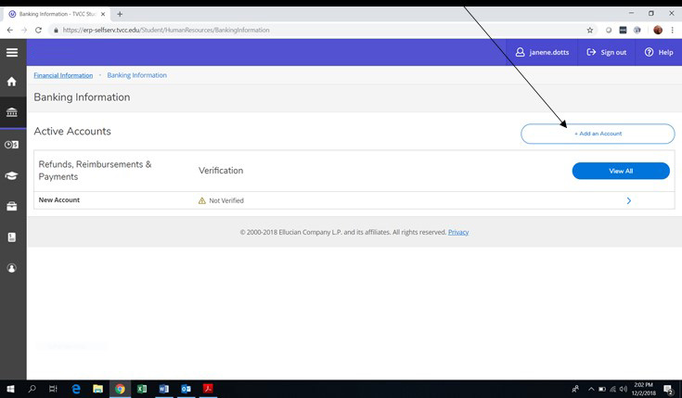

You will be required to confirm your existing bank account number at various stages of change requests. This feature is for your protection to safeguard against unauthorized changes.

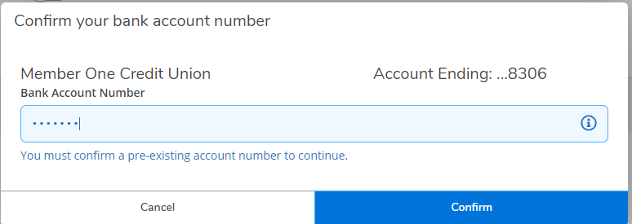

1234

Slide the activation button and then enter the new or updated information as you need.

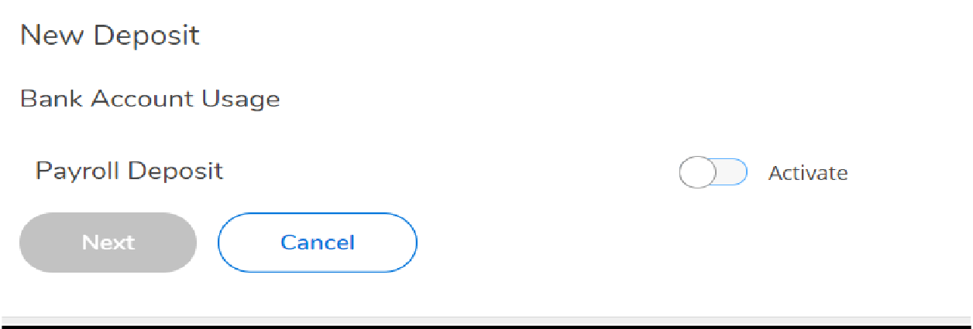

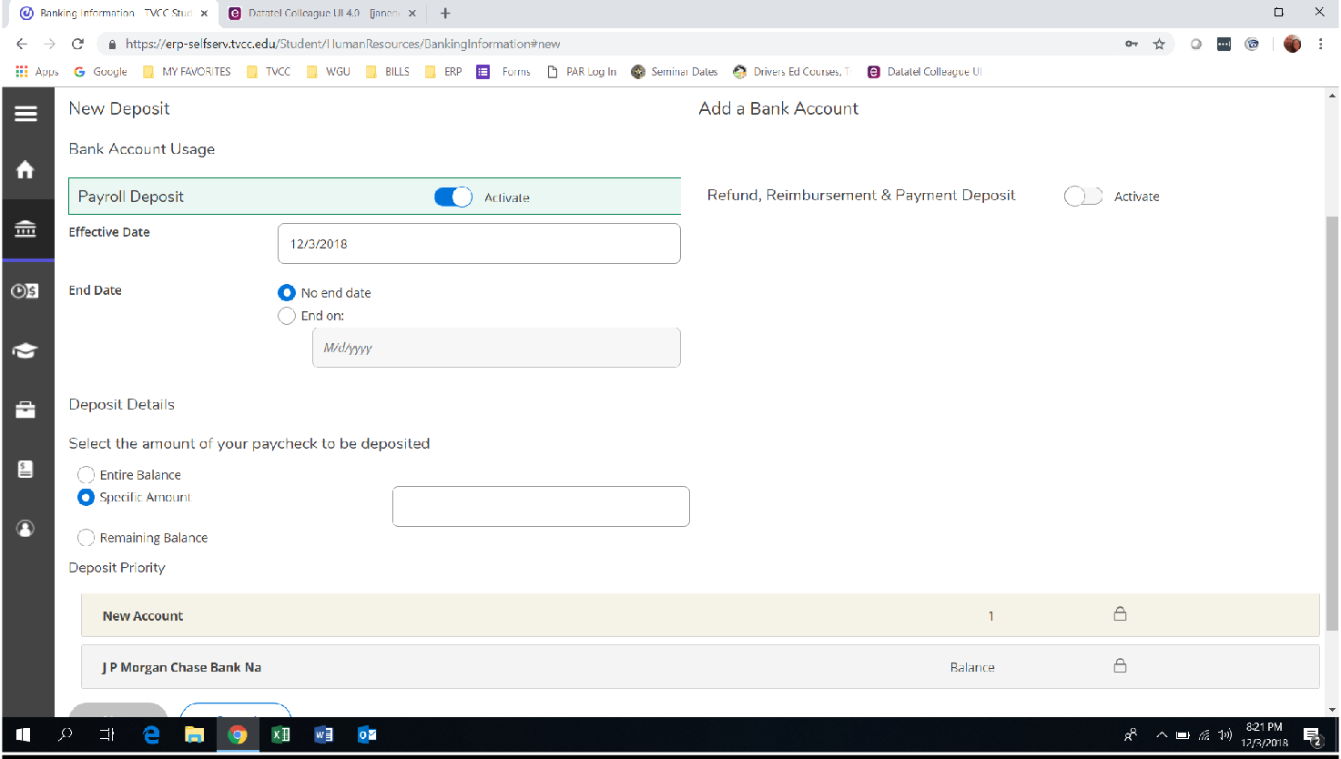

If you are depositing into multiple accounts and want to specify a specific dollar figure, enter as shown below. Then choose “Next”.

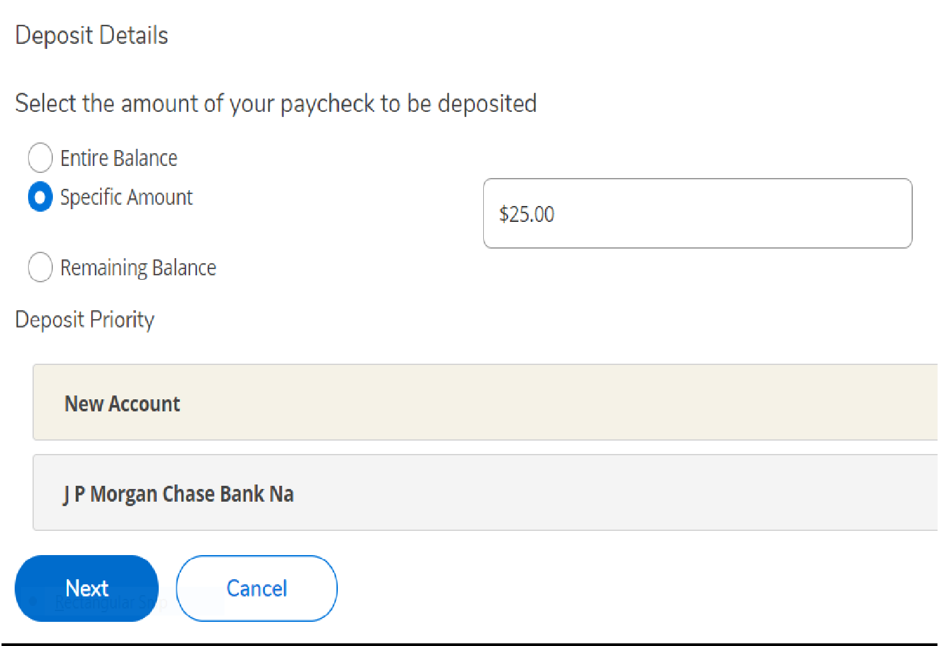

Add banking information in the prompts provided.

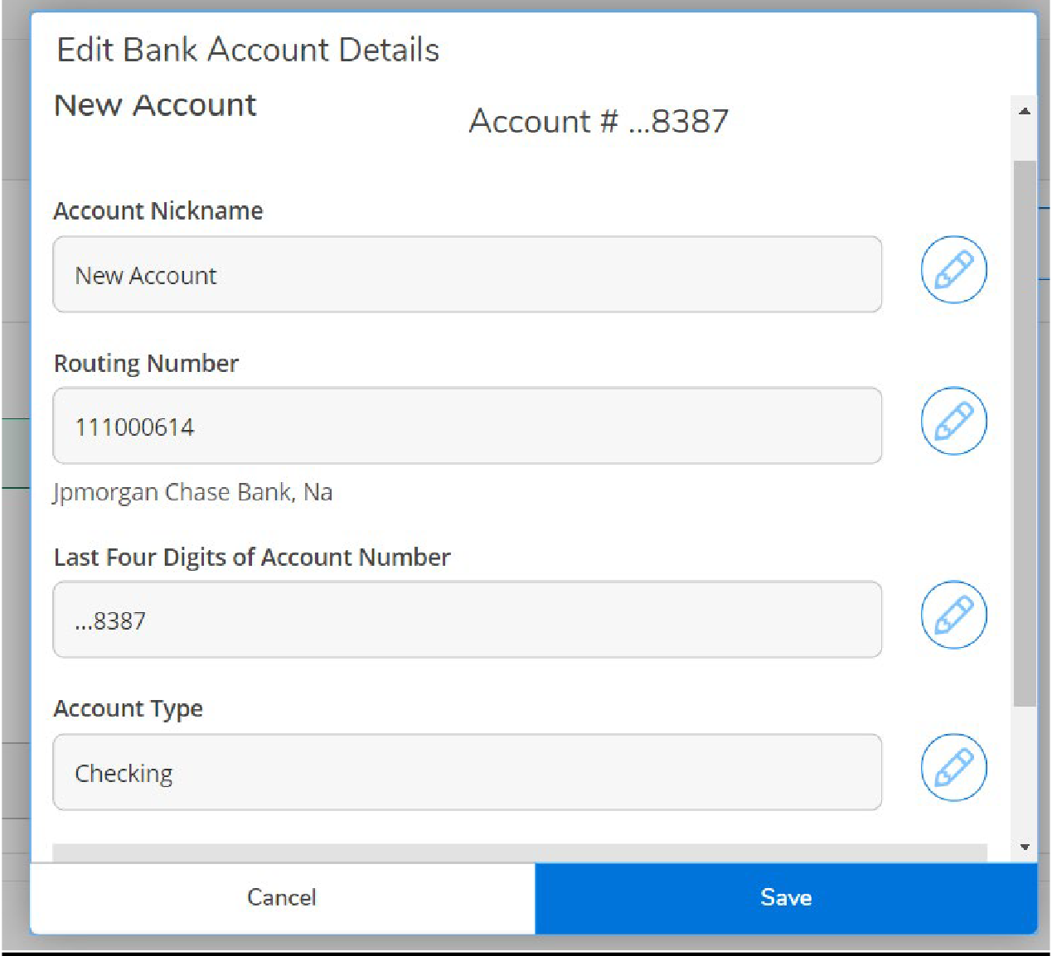

Accept the terms and conditions and save.

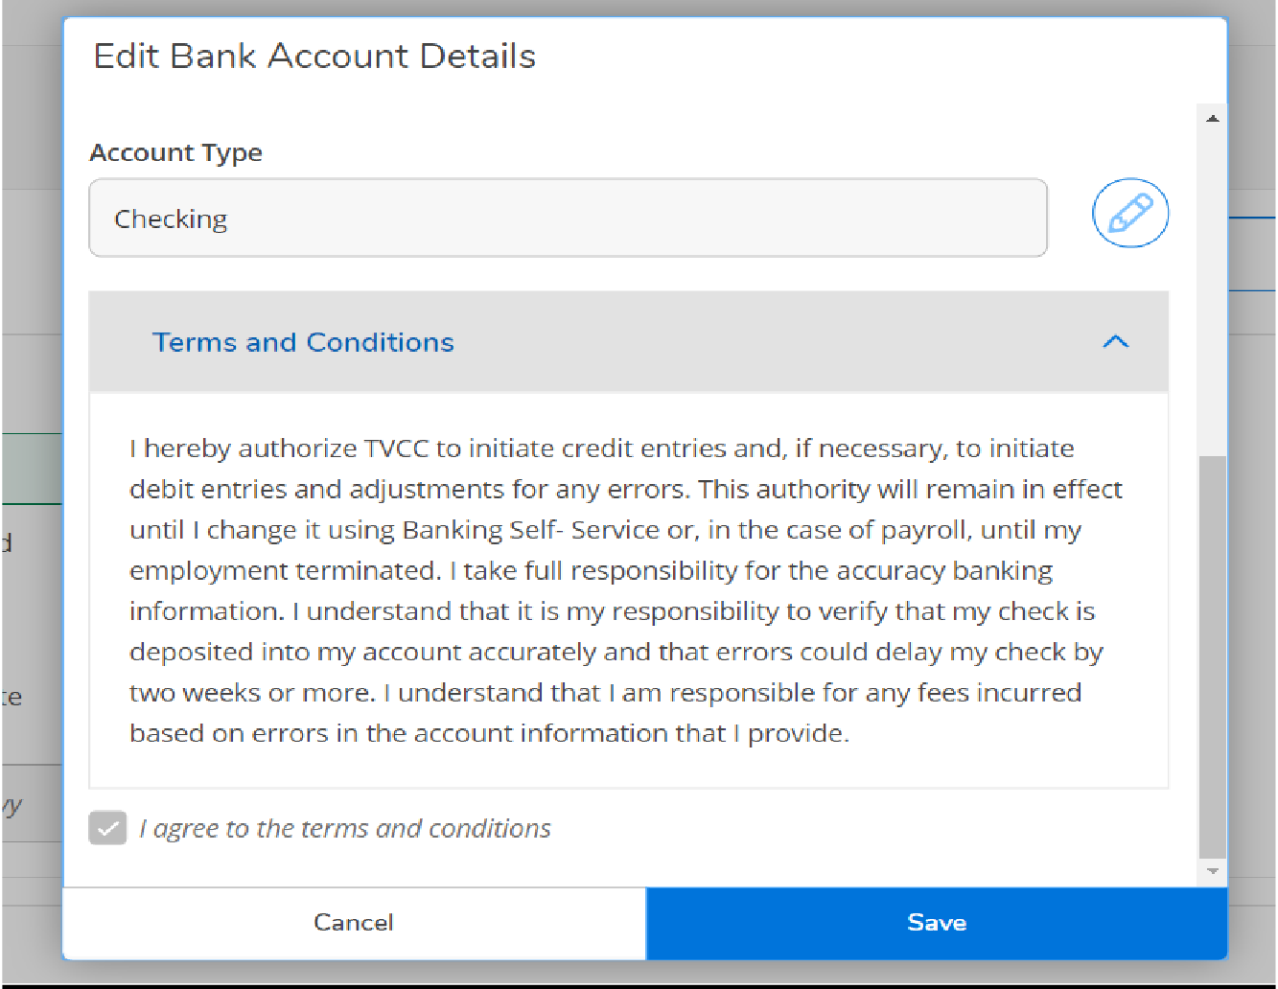

This is what it should look like after you make your updates.

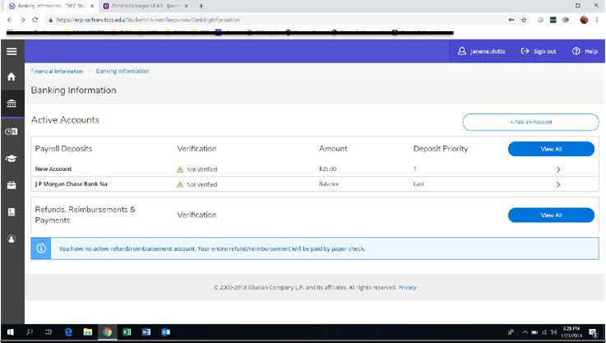

## Employee Earning Statements

To access your Earning Statements in ESS, click on “Earning Statements”

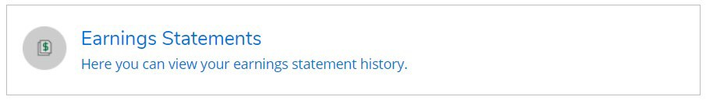

On this screen you can view your Earnings Statements, just click on the date of the one you want to view and it will download. You can open to review or print it out.

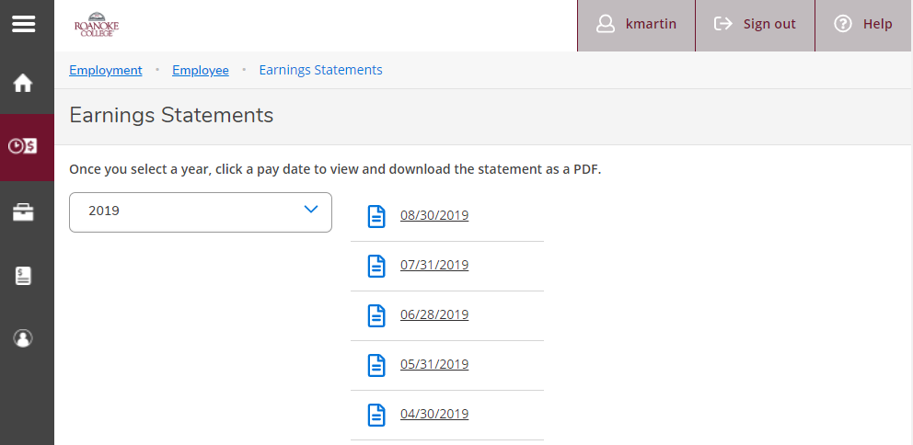

## Employee Leave Balances

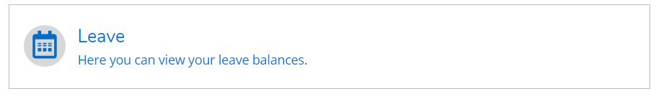In this area you will be able to view your Vacation and Sick/Personal balances. Click on “Leave”.

Notice you can view what you have used and your overall balance in the graphic at the top of the screen. Details about accrual earnings, usage and adjustments are found below.

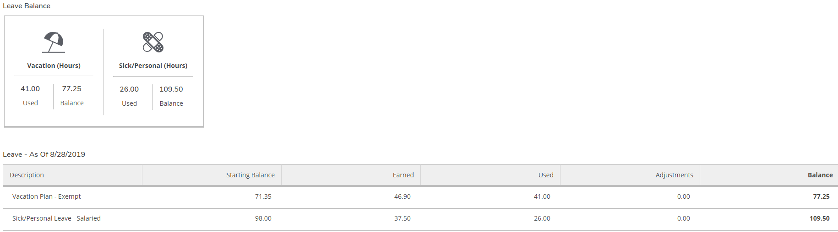

## Time History for Employee

Select Time History

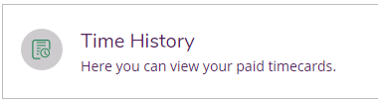

In this section you can view time sheet history. To change to a previous year, click the blue drop down arrow next to the current year at the top of the screen. Click the blue “>” to navigate between pay periods. Expand the time card by clicking the date range on the right side of the screen.

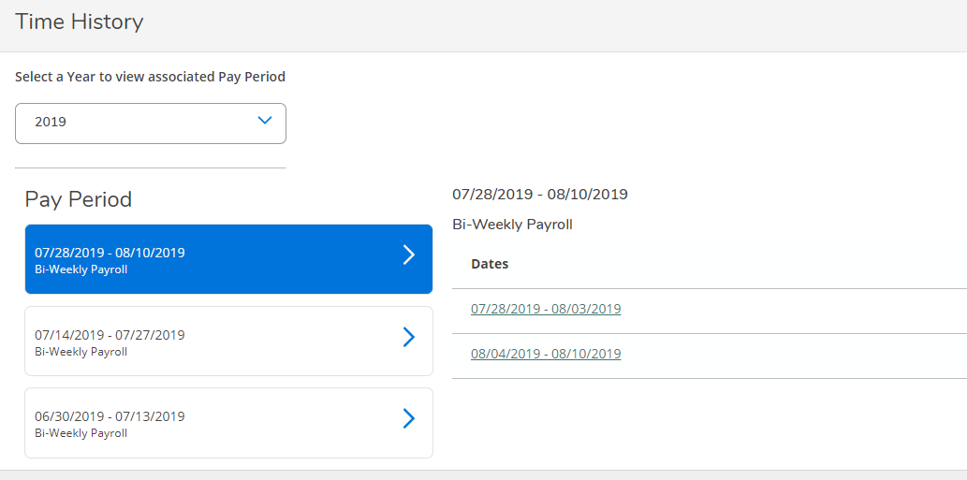

# Time Entry and Approval

## Employee Time Entry

In the Time Entry area of ESS you are able to view, enter, make comments, and submit time worked. To start entering your time in ESS click on “Time Entry”

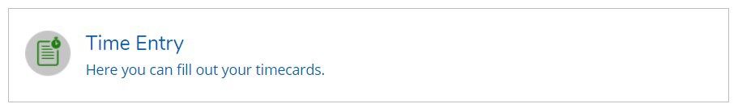

1. Select the pay period and click the blue arrow on the far right to open the timesheet.

*In this example, the person has one job.*

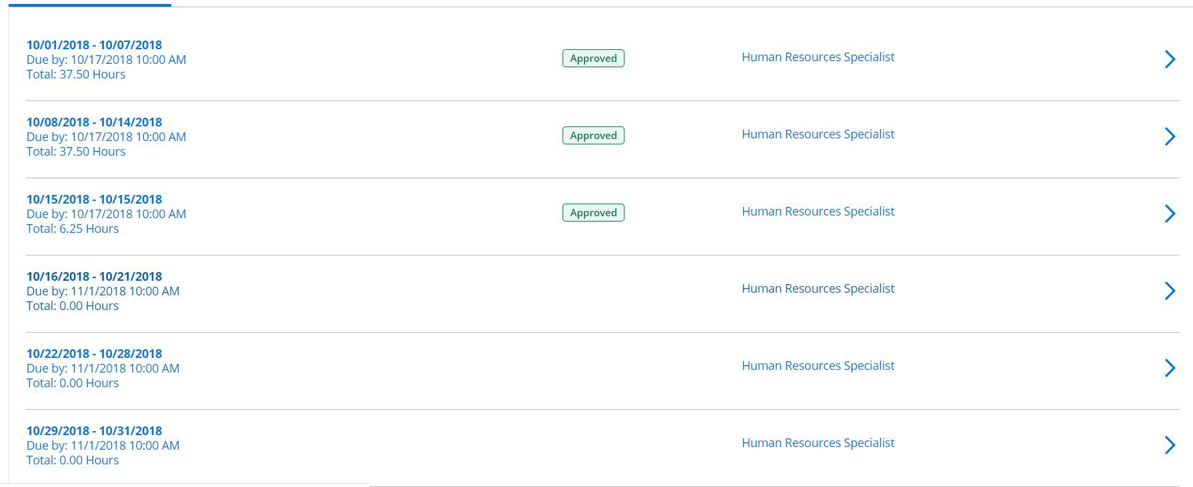

*Multiple jobs will look like this; click the blue arrow to expand all timesheets.*

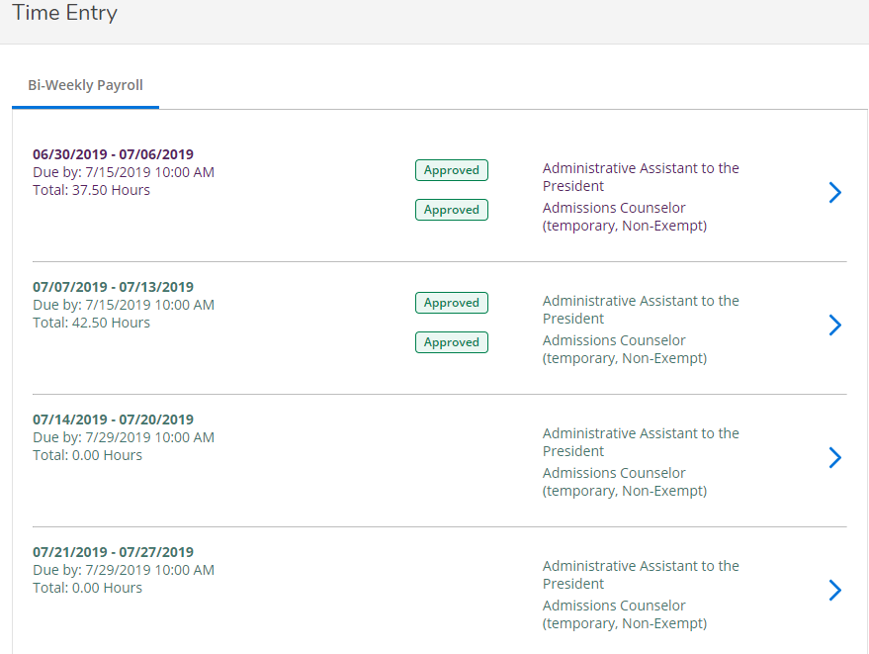

1. Enter Time Worked. Some positions require detailed time entry, others only summed hours per day. Your time will save automatically. There is a Save button but you don’t really need it.

*Detailed time entry (In and out time) view*

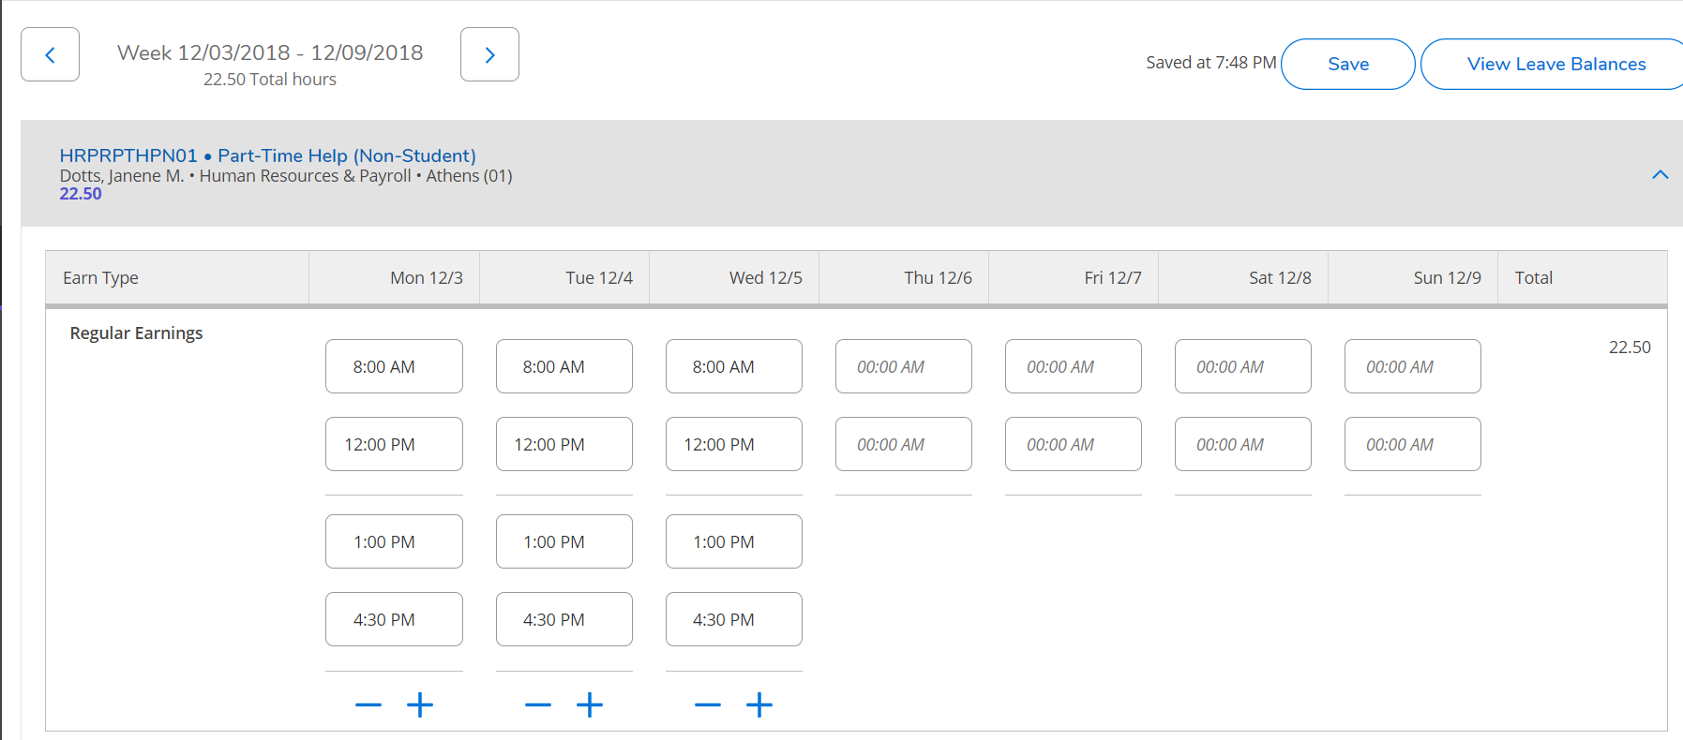

*Total time per day view*

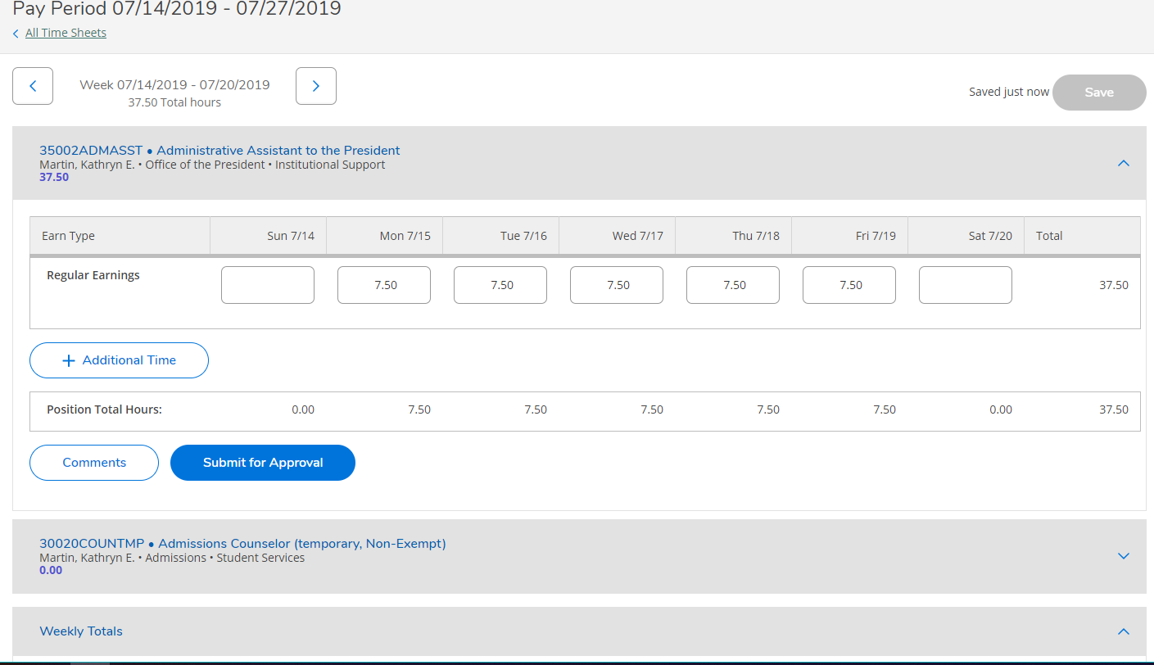

Notice that the arrows toggle back and forth between both weeks in the pay period to allow you to enter time on the correct week.



1. Submit time for approval at the end of each week, or every Monday no later than 10 a.m. for the previous pay week. If you wish to make comments on your timesheet, you must do it before you “Submit for Approval”.

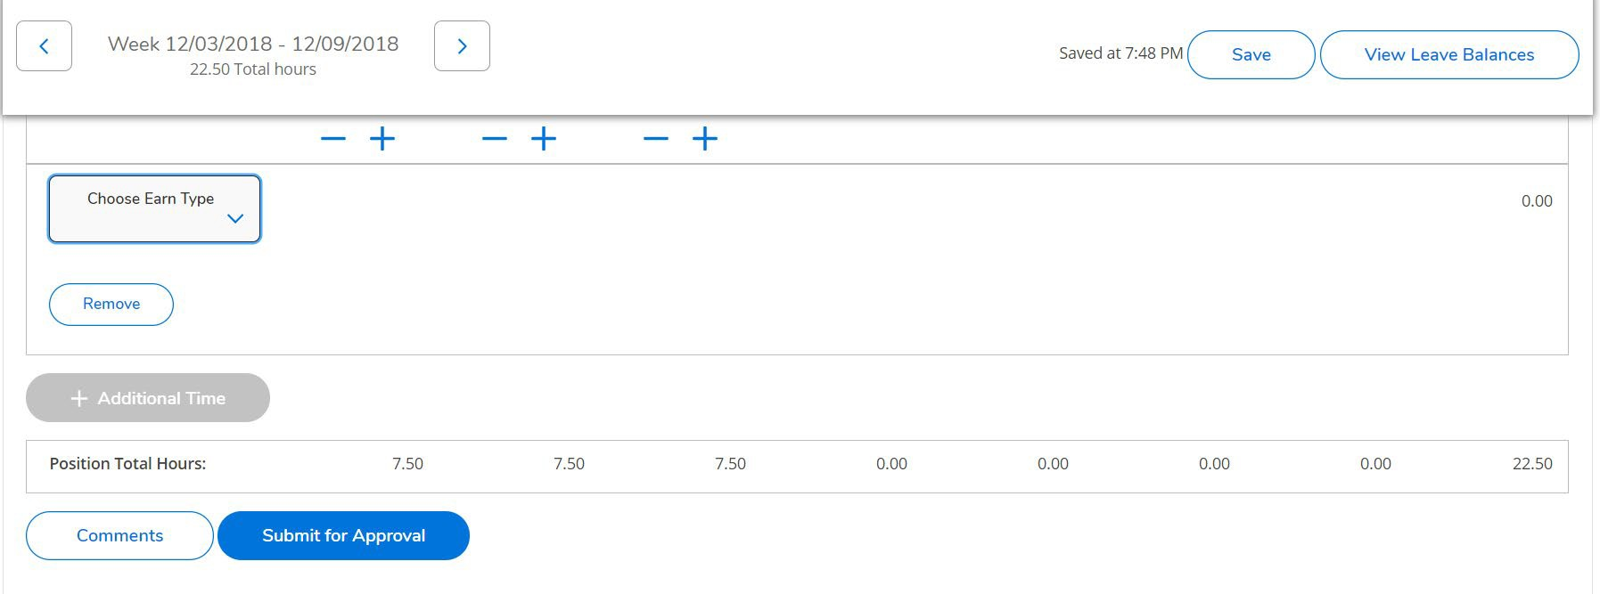

After clicking “Submit for Approval” you will see this pop up in the upper right corner of your screen. Your Supervisor will get an e-mail that you have submitted your timecard.

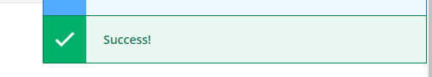

If you made a mistake on a timecard and you need to correct it, click “Return Timecard to Edit”. Once you’ve made your changes, resubmit the time. Keep in mind that your Supervisor will get an email for each action that you make to the timecard.

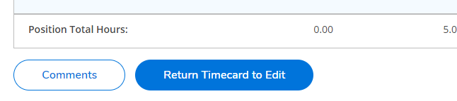

Entering in Vacation/Sick or other Leave Time

1. From your timecard, Select “+ Additional Time”.

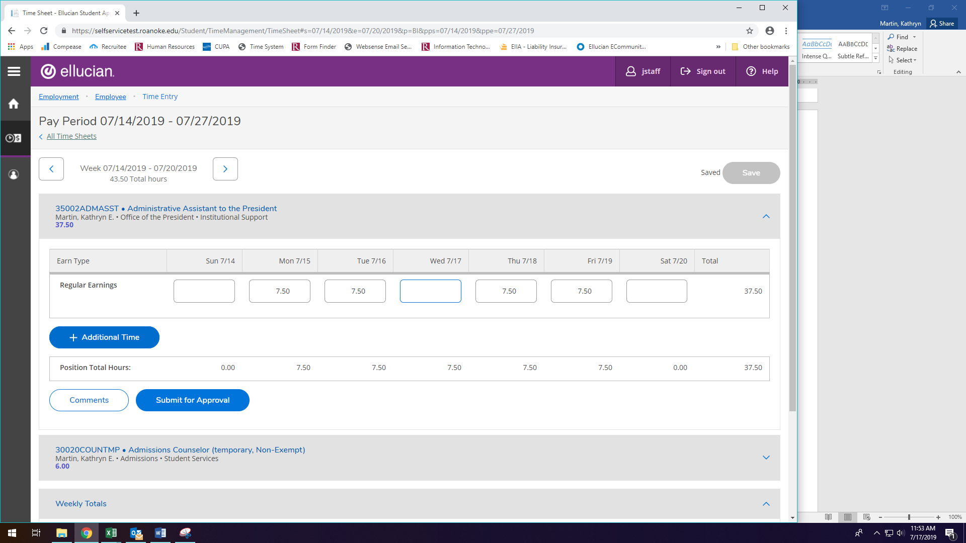

1. Select the earnings type you wish to enter

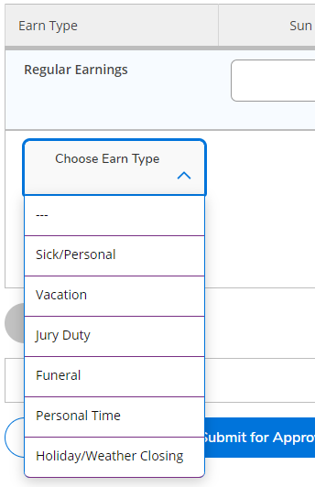

Enter the number of hours on the day of the week in which you took the leave. For this example, we will select funeral leave. Enter the number of hours. You can add other leave types by clicking “+ Additional Time” and repeating the process. Once you are done, you may exit the timecard (remember your time saves automatically) or you can click Save. If you have finished entering time for the pay week, click “Submit for Approval”.

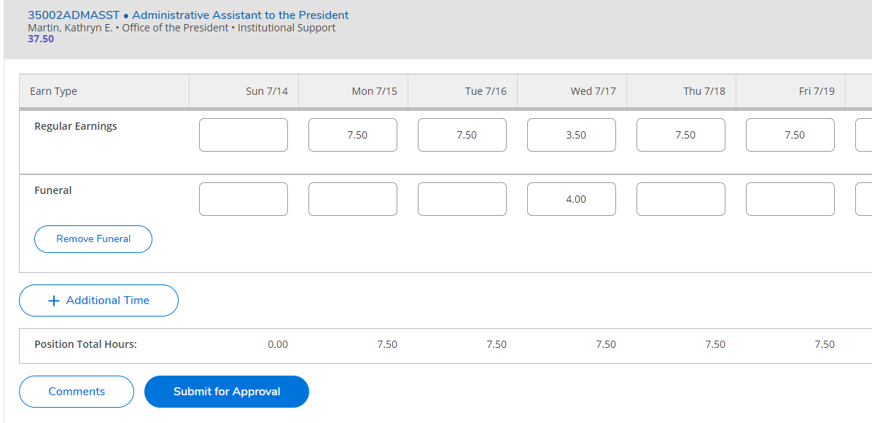

## Supervisor Time Approval

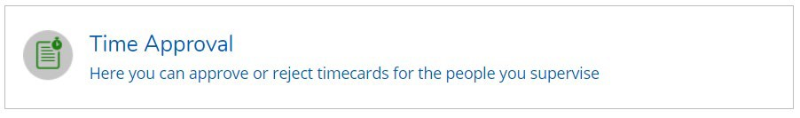To access the time approval screen in ESS, click on “Time Approval”

In the Time Approval area of ESS, you will be able to view, approve, reject, make comments and update your employee’s time. There are multiple ways to do these functions. Any time you approve, reject, make a change, or unapprove a timecard, the system will send an email to your employee that you have done so. (Terminology Tip: “Reject” is used before you approve a timecard to send it back to the employee for changes. “Unapprove” is used after you have approved the timecard and realize that corrections are needed.)

A few general tips about time approval:

* If you are editing time, please note that supervisor screens do NOT save automatically, unlike employee time entry screens. You must “save” your changes as you go along.
* Be mindful of which week you are approving time for as more than one pay period may be open.

All of the employees that you are a time approver for will show up in one list. Notice this list has a mix of bi-weekly staff and student employees. The tabs differentiate student from staff payrolls.

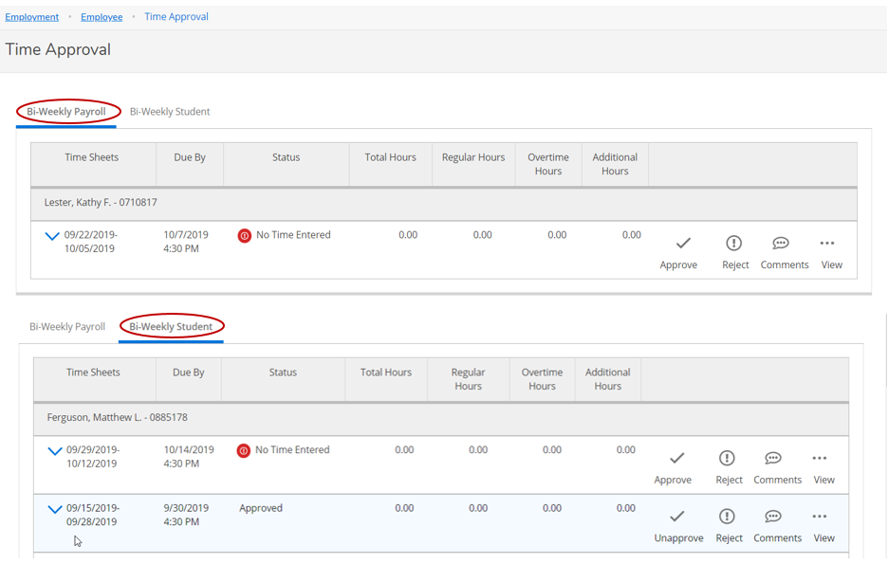

Supervisors have the option to approve, reject, add comments or view. You have several ways to do all of these. Here is where you do it from the main screen.

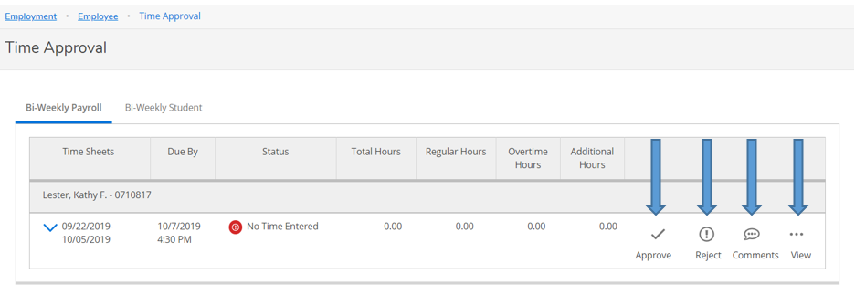

You can click on the “view” to see the timecard detail. It is highly recommended you do this before approving timecards. You can edit the employee’s timecard from here, as well as approve.

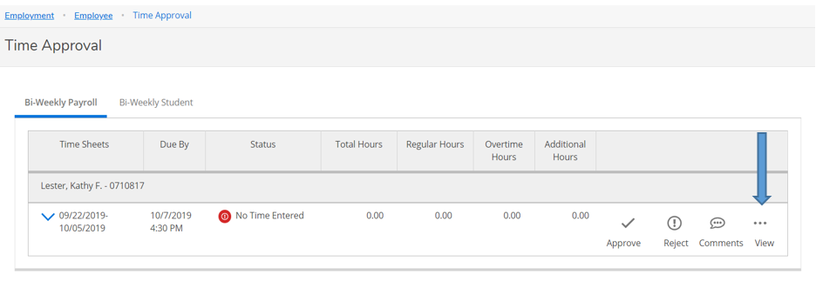

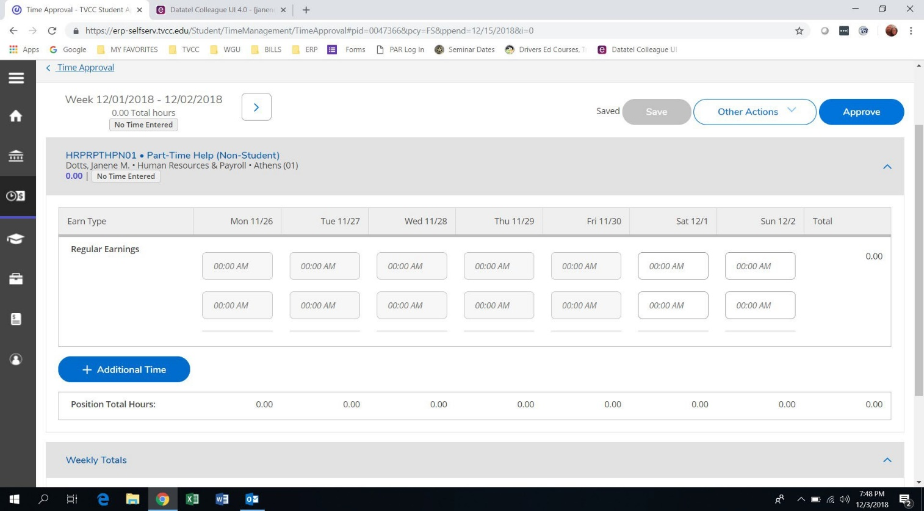

If you wish to add a comment, you must do it BEFORE you approve the timecard. If you forget, you will need to unapprove the timecard, make the comment and approve again. (Note: Your employee will get an e-mail when you unapprove the timecard, and again when you approve it.)

Another option is to click “Other Actions”; you can add comments and approve or reject from here.

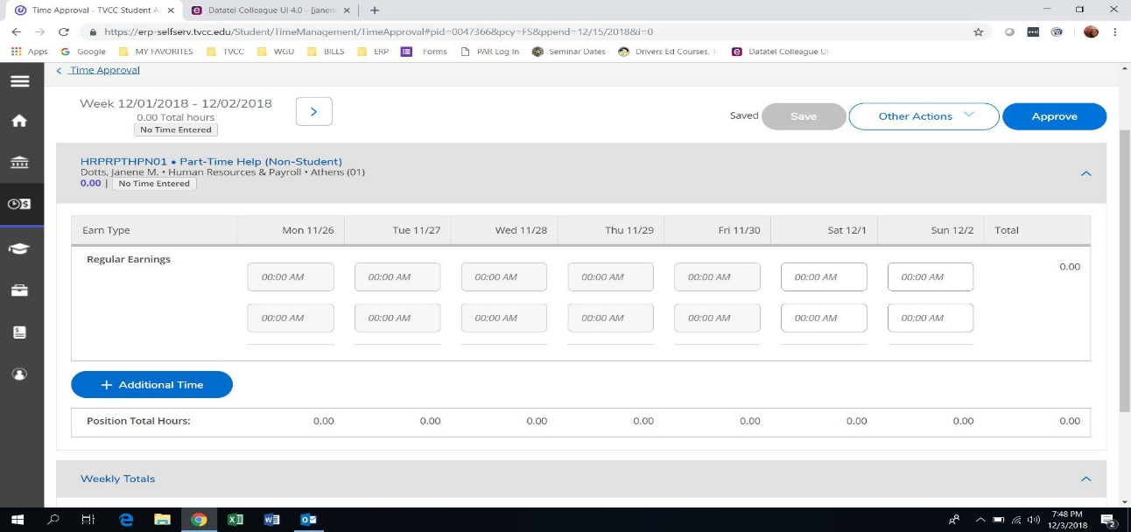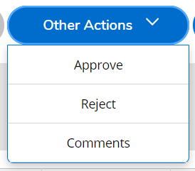

If your employee forgot to add leave to their timecard, you can add it for them or reject the timecard, sending it back for them to edit. Click “+ Additional Time” to edit time.

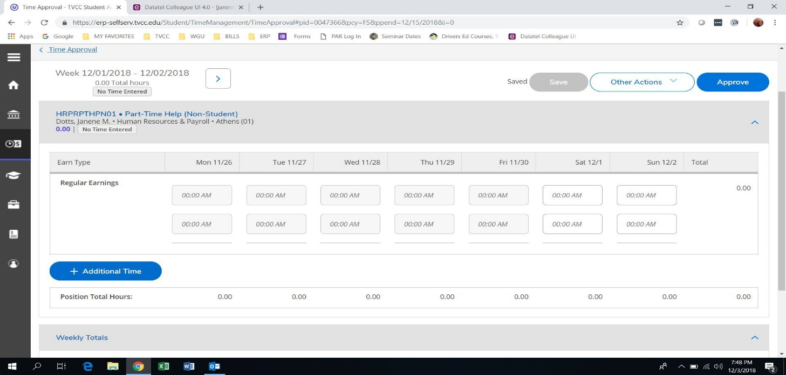

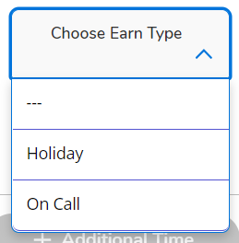

After you click on “+ Additional Time” choose the description that matches the time you need to enter for the employee. Key in the hours on the date the leave was used.

After you add the additional time, if you need to remove it you can click on “Remove”.

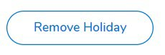

Once you have approved the timecard, green “Approved” boxes will appear and you are done with the employee.

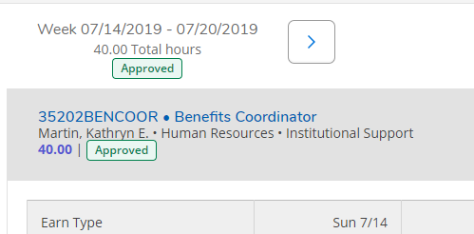

## Set up a Timecard Proxy Approver

To access the employee proxy area in ESS, click on “Employee Proxy”.

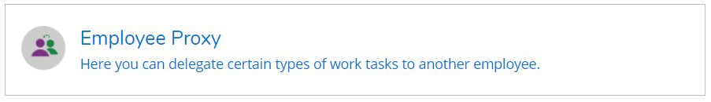

Click “+ Add Time Approval Proxy”

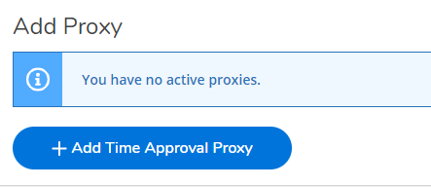

Enter the name of the person you would like to approve your timecards and select their name from the list that pops up. Once selected click “Add Proxy”. The system is not date sensitive. Once you set up a proxy, it goes into effect immediately and stays on until you remove it.

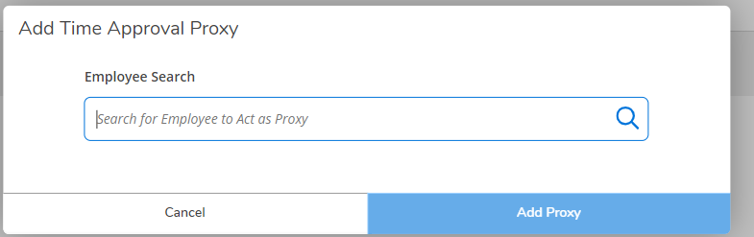

When you are finished, it will look like this. Click the red circled X to remove a proxy.

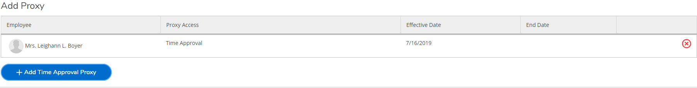

If you are the proxy for someone else, this is the screen you will see when you log in. You can toggle back and forth between your own timecards and the person you are filling in for.

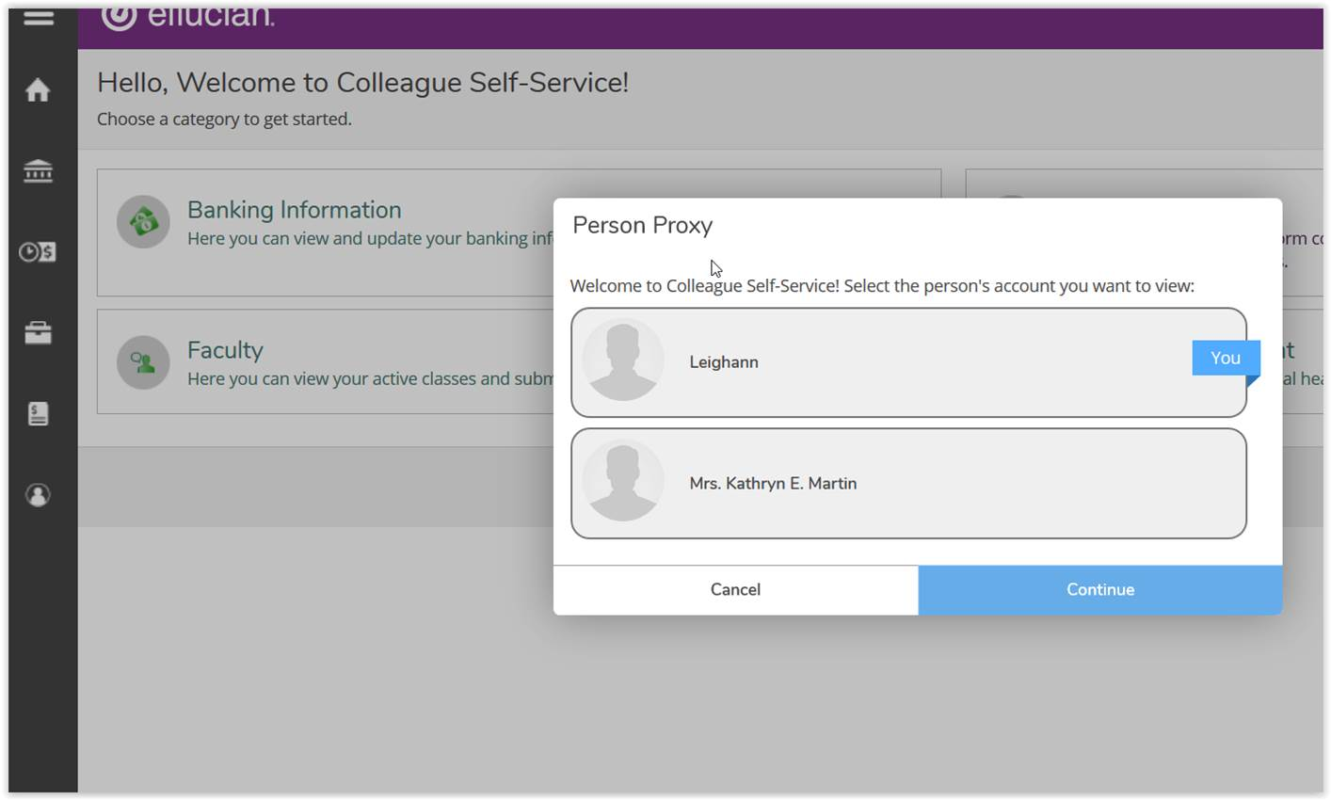

If you have been proxied, you can toggle back and forth between your t

## 

## Time History for Supervisor

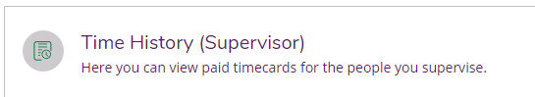

Enter in the name of the employee you would like to view and execute the search.

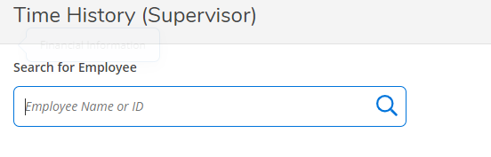

Once you have found the employee you are looking for, select the pay period and specific dates you wish to view. To change to a previous year, click the blue drop down arrow next to the current year at the top of the screen. Click the blue “>” to navigate between pay periods. Expand the time card by clicking the date range on the right side of the screen.

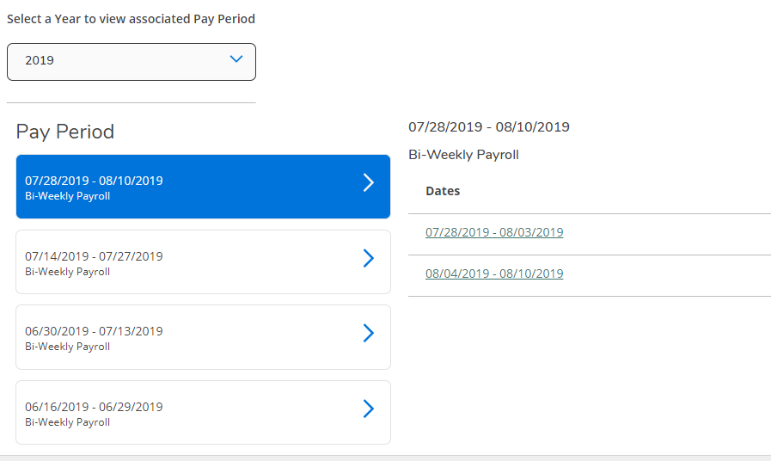

# Logging Off

You should always log off of ESS by exiting using the “SIGN-OUT” link as shown below.

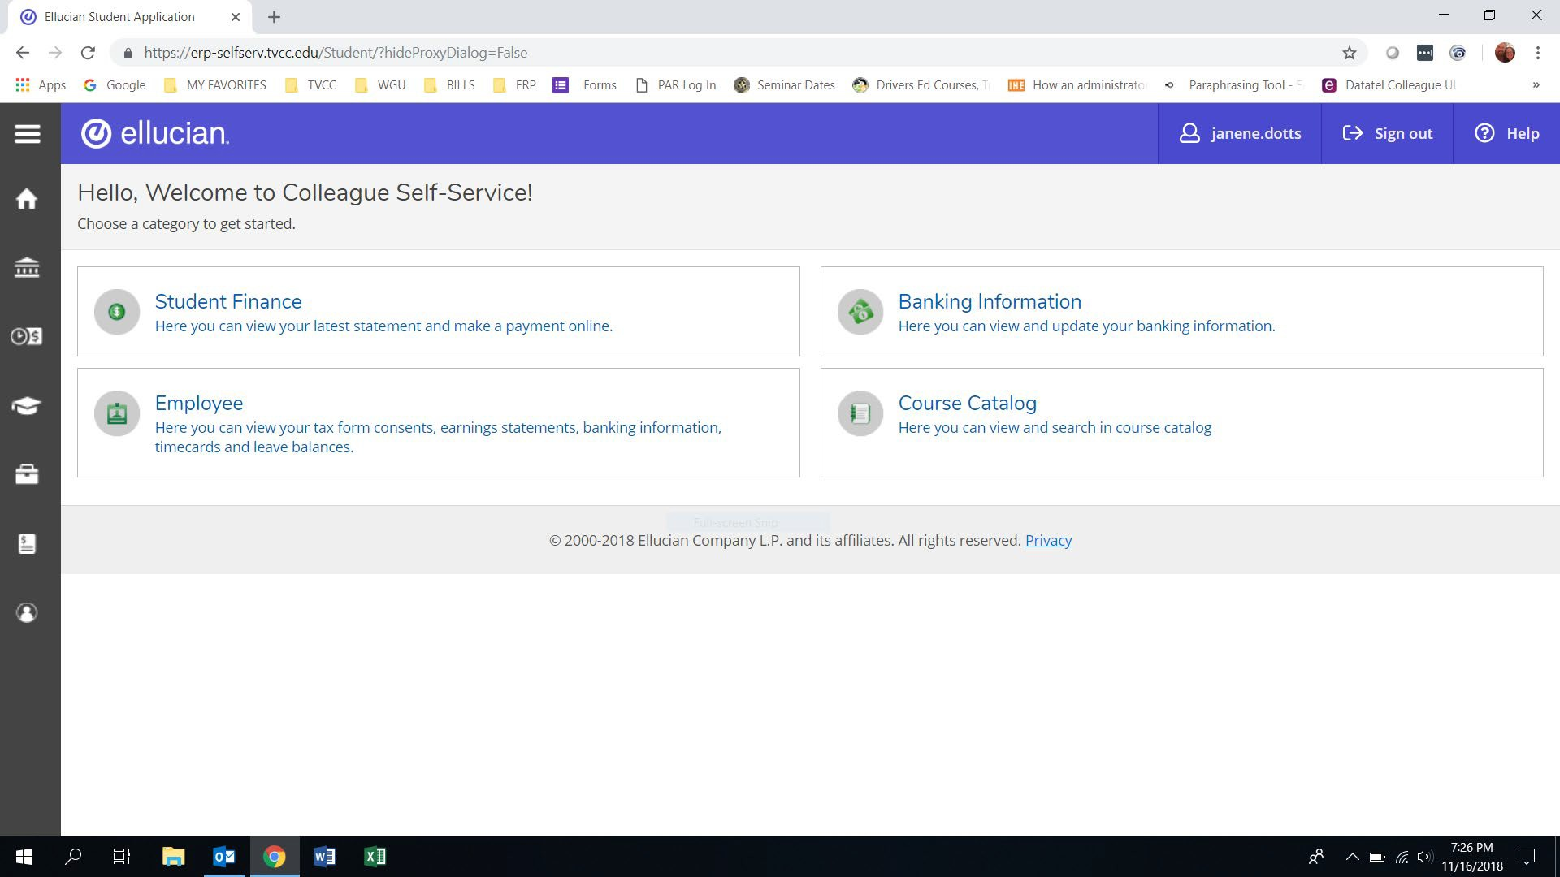

# 

# Help and Support

Help will be available to all ESS users by contacting Payroll or Human Resources during the hours of 8:00 AM – 4:30 PM on Monday – Friday.

|  |  |
| --- | --- |
| Payroll  [payroll@roanoke.edu](mailto:payroll@roanoke.edu)  375-2014 | Human Resources  [hr@roanoke.edu](mailto:hr@roanoke.edu)  375-2455 |