Staff Time Entry - Computer

From the Inside Roanoke homepage (www.roanoke.com/inside), select “Self Service”. (You may also enter time from Ellucian Go on your mobile device. Those instructions are found in another document.)

If asked, log in with the same User Name and Password that you use for other campus systems.

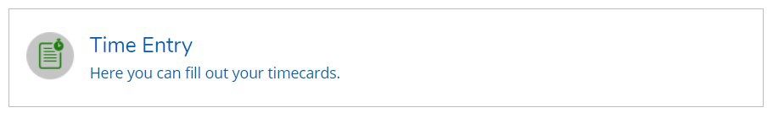
After logging in to Self Service, click on EMPLOYEE and then click on TIME ENTRY to enter your time.
In the Time Entry area of ESS you are able to view, enter, record leave, make comments, and submit time worked. Your supervisor will receive emails when actions are taking on your timecard, such as a request to approve. You will receive emails when your supervisor makes changes to your submitted timecard, such as approving or rejecting.
Select the pay period and click the blue arrow on the far right to open the timesheet. In this example, the employee has one job.

Multiple jobs will look like this; click the blue arrow to expand all timesheets.

Enter Time Worked (total hours worked that day). Your time will save automatically. There is a SAVE button but you don’t really need it. In the example below, time has been entered for one job. If hours were worked in another job, that timecard would need to be opened and the process repeated. You may also make comments from this screen. Once all time has been recorded for the week, click SUBMIT FOR APPROVAL to send the timecard to your manager for approval. (Note: If you have a paid leave to enter, those instructions appear later.)
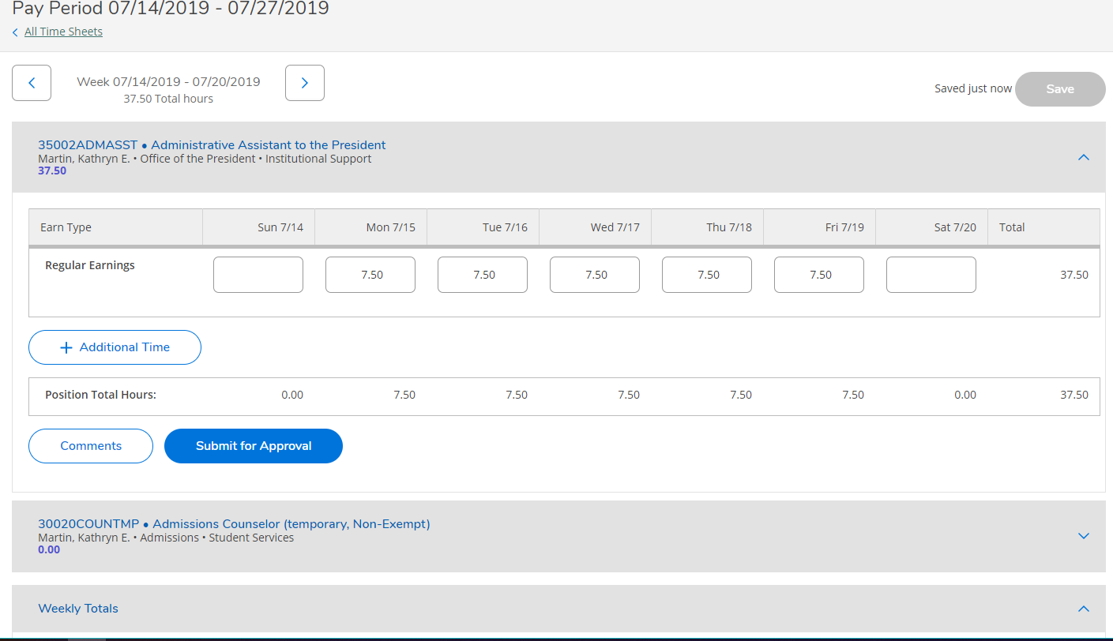
Notice that the arrows toggle back and forth between both weeks in the pay period to allow you to enter time on the correct week.

Submit time for approval at the end of each week, or every Monday no later than 10 a.m. for the previous pay week. Please edit and submit time weekly. If you wish to make comments on your timesheet, you must do it before you SUBMIT FOR APPROVAL.
After clicking SUBMIT FOR APPROVAL you will see this pop up in the upper right corner of your screen. Your Supervisor will get an e-mail that you have submitted your timecard.

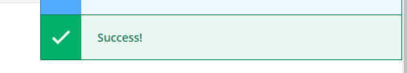

If you made a mistake on a timecard and you need to correct it, click RETURN TIMECARD TO EDIT. Once you’ve made your changes, resubmit the time. Keep in mind that your Supervisor will get an email for each action that you make to the timecard.
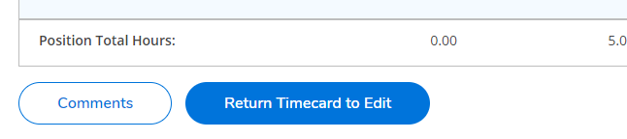
Entering in Vacation and Sick Time and other leave types

From your timecard, Select “+ ADDITIONAL TIME”.

Select the earnings type you wish to enter
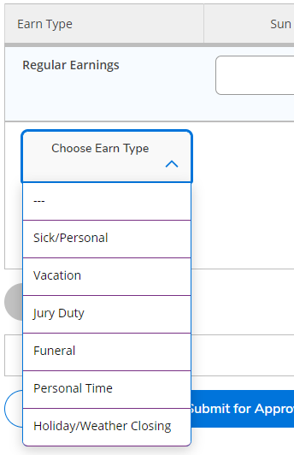

For this example, we will select funeral leave. Enter the number of hours. You can add other leave types by clicking “+ ADDITIONAL TIME” and repeating the process. Once you are done, you may exit the timecard, your time saves automatically, or you can click SAVE. If you have finished entering time for the pay week, click SUBMIT FOR APPROVAL.
