|  |  |  |
| --- | --- | --- |
|  |  |  |
| **SUBMITTING EXEMPT LEAVE REQUEST IN EMPLOYEE SELF-SERVICE** | |
|  | | |

1. Log into **Employee Self-Service**
2. From the home screen, select **Employee**

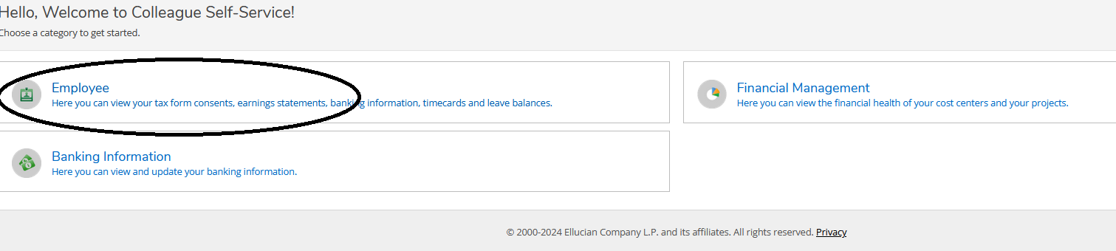

1. Select **Leave**

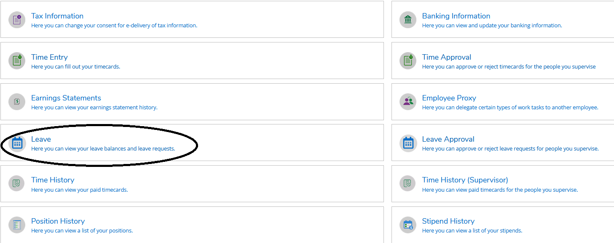

1. On the leave summary page, click **Request Leave** located in right corner

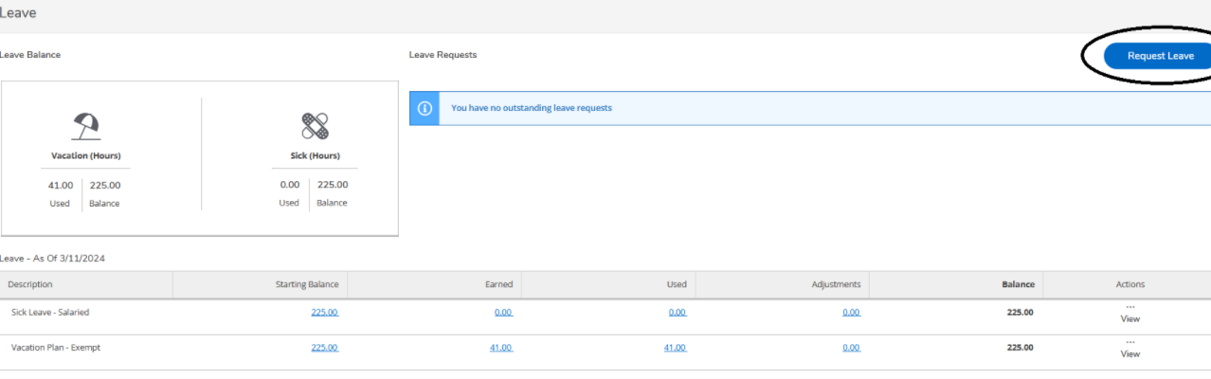

1. On the leave request detail page, select the **Leave Type** you are requesting (sick leave or vacation leave)
   * After you choose your leave type, your balances will populate on the right-hand side of the screen.
2. Enter the **Start Date** and **End Date** for the requested leave
   * You **MUST ENTER HOURS IN THE START AND END DATE**
   * The start and end dates can span any length of time
   * If you are only taking one day of leave the start and end dates will be the same date
3. Enter the **Hours** requested in the provided fields

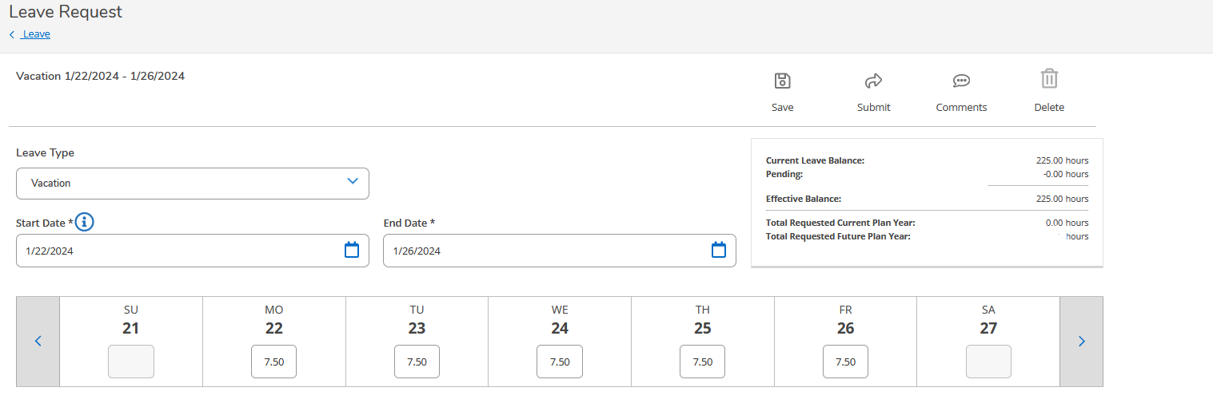

* + You are not required to enter hours in every day in the time span between the start and end dates unless you want to take those dates off. The total time off you are requesting will be listed in the box above the calendar once you add time to the dates you are requesting off.

1. When finished you have the option to:
   1. **SAVE** to create a draft of your leave request and the request **WILL NOT** be sent to your supervisor
   2. Add a **COMMENT** to create a draft of your leave request. The comment can be seen by your supervisor once you **SUBMIT**
   3. **SUBMIT** your leave request for your supervisor to approve
      1. The request will then show on the left-hand side under Outstanding Leave Requests that you have submitted the request.  
         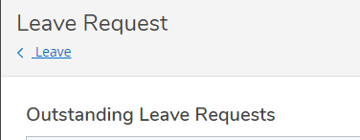
      2. In that box you will be able to see if the request has been submitted or is just a draft:  
           
         
      3. The box on the left side of the screen will look like the below but, will have everything filled out on the right side of the box:  
         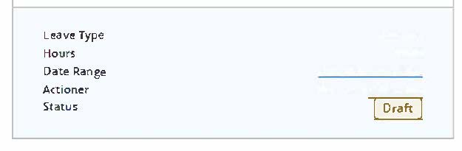
   4. **DELETE** your leave request all together
2. Once you are done click to go back to the Leave screen by clicking Leave under Leave Requests  
   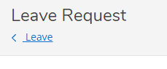
3. This will take you back to the Leave screen where you will be able to see your Leave Requests on the right-hand side under the Request Leave button.  
   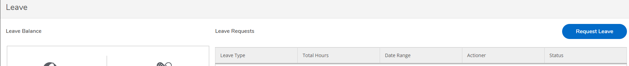

|  |  |  |
| --- | --- | --- |
|  |  |  |
| **TIPS, TRICKS AND HELPFUL TOOLS** | | |
|  | | |

1. You may check your leave balances at any time via the **LEAVE** section in Employee Self-Service



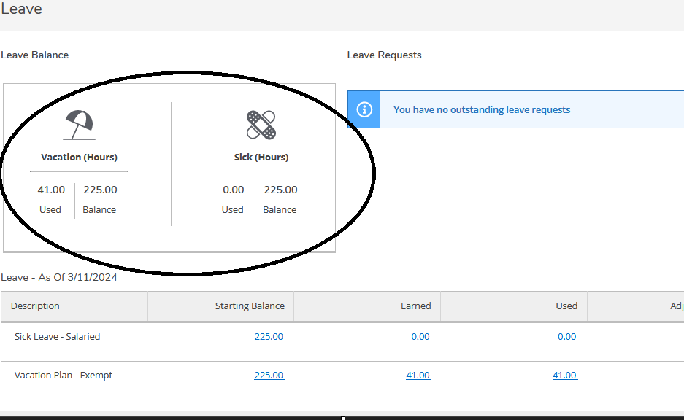

1. You can **Unsubmit** your leave request after you submit it if you need to. When you click on your submitted request you will see these options:

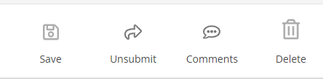

* + After you **Unsubmit** the request, you will have the option to submit it again after making a change if needed.

1. After your request has been approved you can **Withdraw** the request. These are the options you will then see:



* + Once you click **Withdraw** you will get a pop-up to enter your reason for withdrawing. After adding your reason, you can click on **Withdraw**.

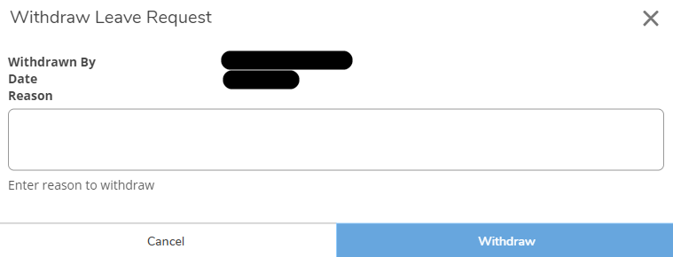

* + When you go back to your Leave screen you will see this in the status of the request you requested to withdraw:



* + 1. When you hover over the page next to Approved you will see this:

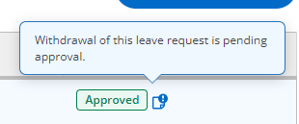

* + 1. Once your supervisor approves the withdrawal the status will change to:



* + 1. You can then go back into the request and delete it. Once you click **Delete** you will see:

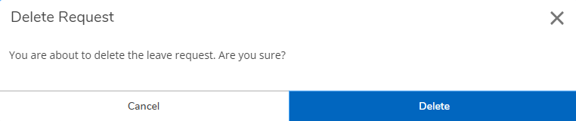

* + 1. Click **Delete** if you really want to delete the request. Or **Cancel** if you just want to go back into the request and change something before submitting again.