Payment Request Instructions

In Self-Service:
Go to Daily Work
Financial Management
Procurement
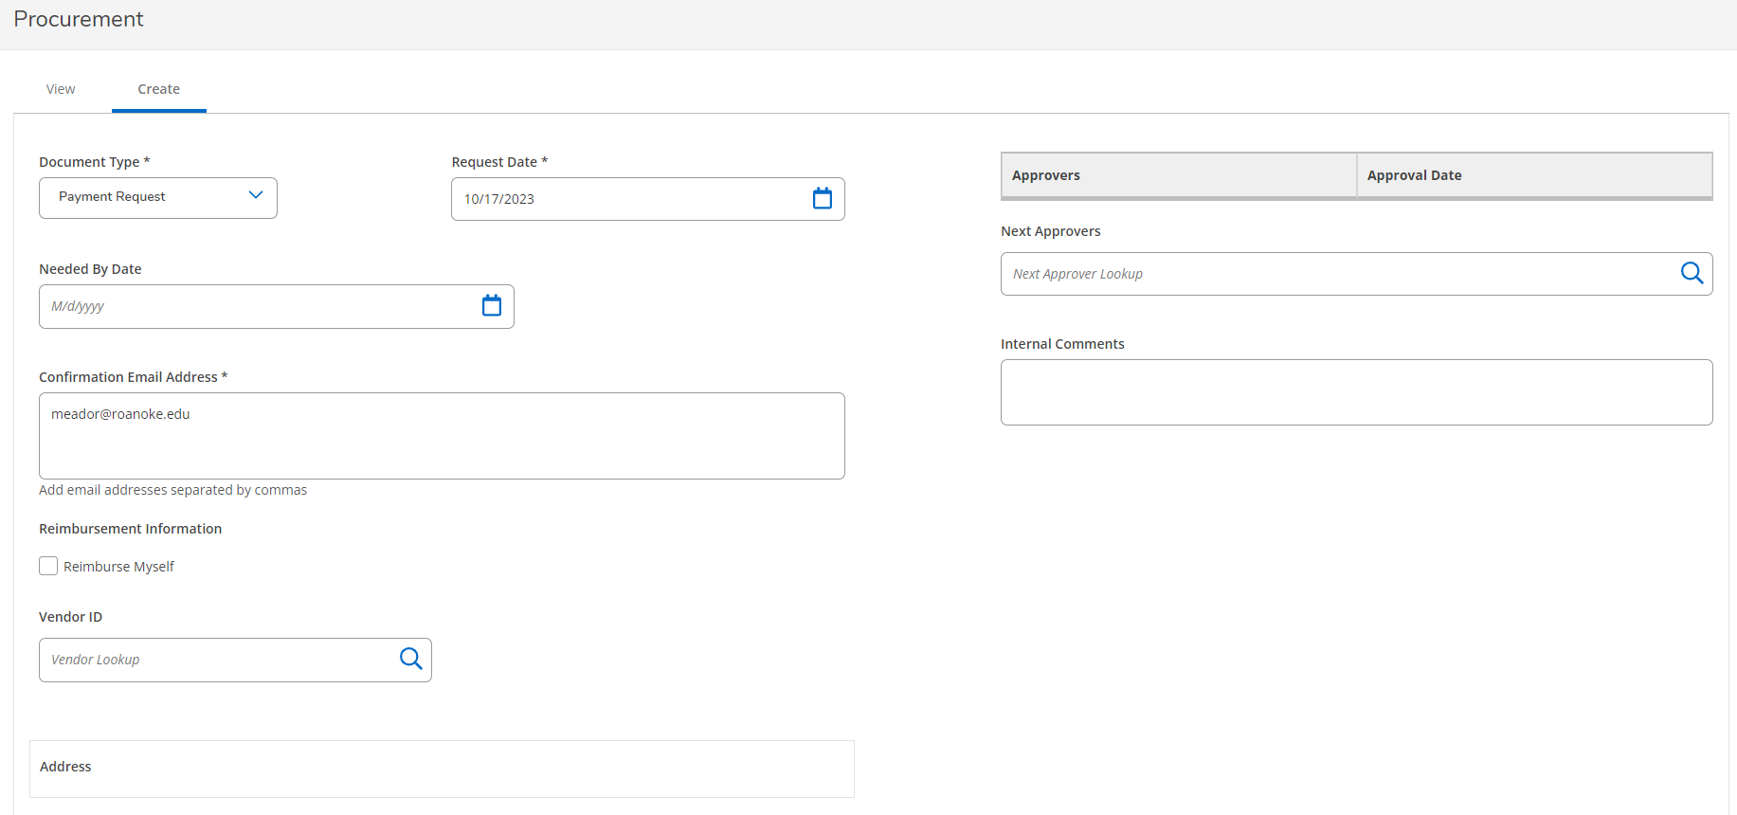
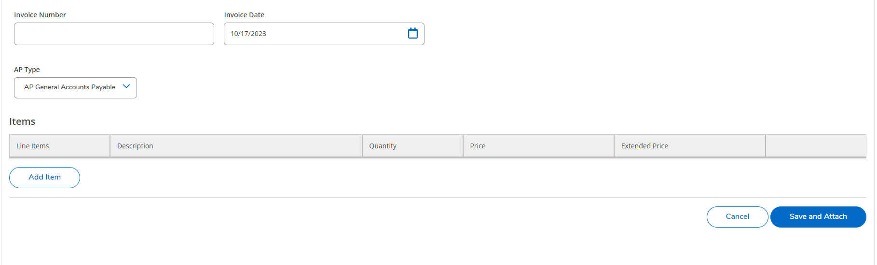
Click the Create tab
Put in the following:
- Document Type
  - Always will be Payment Request
- Request Date
  - Date the invoice was mailed or expense was incurred.
- Needed By Date
  - Due date of the invoice or date that it needs to be paid by
  - If it is past the due date, you can just put in today’s date.

- Next Approvers
  - You will need to put your name in the Next Approvers box and press enter so that you can be marked as the first approver on the request.
  - To add the next approver, you will do the same thing with typing the name of the person that needs to approve your request.
- Internal Comments
  - These are for your records. If you need to put something in there so you know exactly what the payment is for without looking at the backup you can put those notes here.
- Make sure your email address is showing in the box correctly
- If you are requesting reimbursement to yourself check that box If not,
- Select Vendor ID.
  - Start typing the name of the Vendor or if you know their vendor ID number you can type that in and press the search button or enter
    - For example “City” for City of Salem or Roanoke or “Sani” for Sanico
    - If you do not find the vendor you want to pay they are likely not in our system. You will need to ask for their W-9 and submit it to our office through the accountspayable@roanoke.edu email along with a copy of the invoice and request that we set them up in the system. Once they are set up we will email you with their vendor number so that you can enter the payment.
      - If it is a student or employee that doesn’t come up they will need to be set up in the system as a vendor as well. Please email accountspayable@roanoke.edu for us to set them up as a vendor. We do not need a W9 in this case. Students and Employees will also need to have their banking information set up in Self-Service so, that we can pay them electronically.
  - Make sure to select the “check address” if one is available. If not, the next one to pick would be AP. Be sure that there is an address showing with the Vendor name or you will get an error when you try to submit it.
- Invoice number and date
  - If there is no invoice number put in either something brief for example SERVICES, FEE, REIMB, or DUES and the amount or month/year after those.
- AP type will always be AP General Accounts Payable
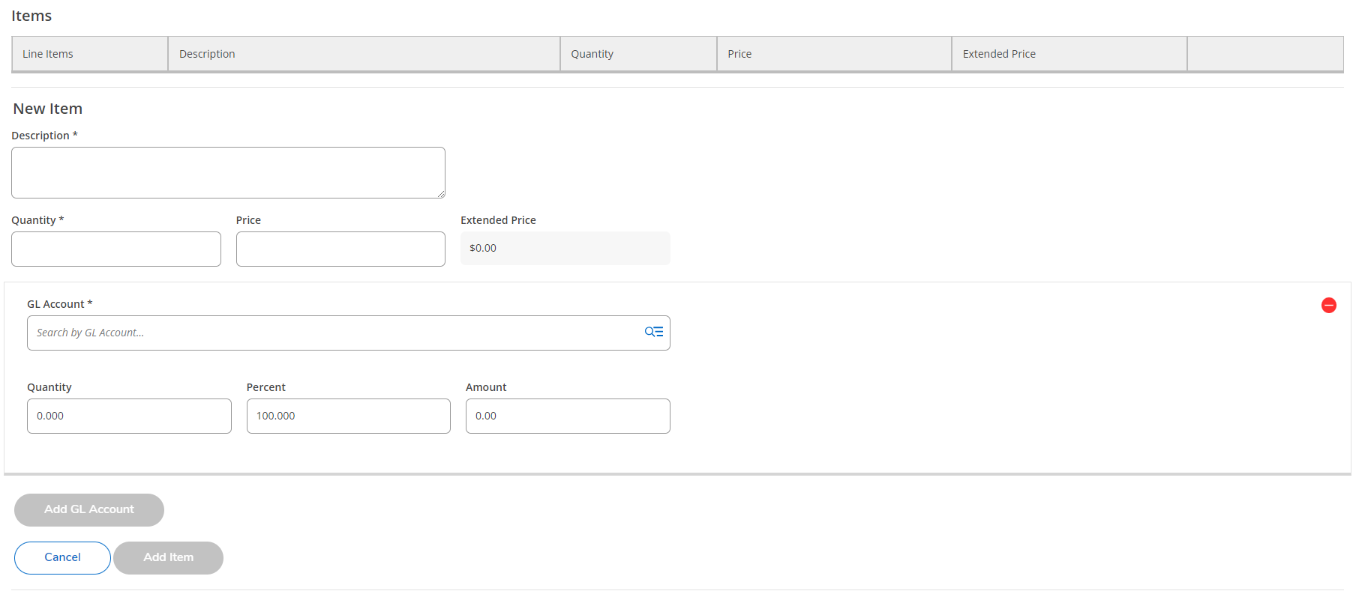
- Then add the line items to be paid by clicking Add Item
  - Input the Description
    - For the Description keep it brief. This will appear on the GL and reporting so it needs to be something meaningful for you to know what it was for. For example: Cell Phone Bill Aug 24 or Renewal 3/24-2/25.
  - Quantity and Price
    - 1 and the total of the invoice.
  - GL Account number
    - To add an account just start typing the number in and it will start to auto populate for you and you can scroll down to pick the one you want or just continue typing. You can also search by words that appear in the GL account name, such as “institute.”
    - To add more than one, just click on the Add GL Account button to put in the next account number in. If you are splitting between different accounts then put the amount in for each account and the Quantity and Percent will automatically fill in for you.
  - If you need to add another line item just click on the Add Item button and repeat the above.
    - This isn’t something that will be common. It will be more common to split between different GL Accounts. An example of when this would be used is if you are paying someone an Honorarium and a reimbursement at the same time. You would add one line for the Honorarium amount as that would be a taxable item and then the second line would be for the reimbursement which is not taxable.

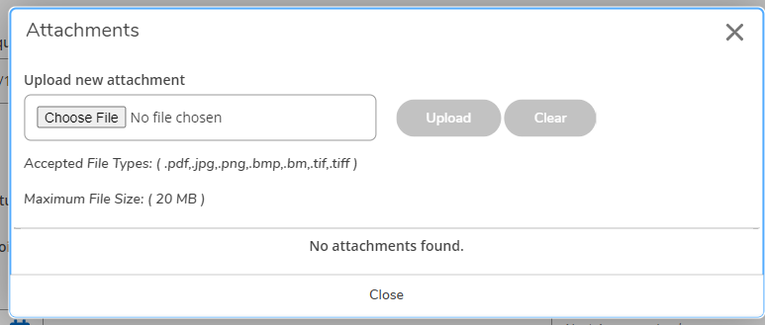

- Save and Attach
  - Attach the invoice and/or payment backup
    - Choose a PDF file then click upload
    - Once done click close to exit that box and return to the modify request screen.
      - From here you can check the approvers list to make sure the correct approver is showing and you can also add another approver in if you need/want to.
      - Click on View at the top to exit the request.

On the View tab you can see all the requests that you have made and if they have been approved, returned, outstanding, voided or paid.

Once the request has been made you will receive a confirmation email. If the account is over budget that email will tell that and by how much.

If you need to change anything on a voucher just pick it from the list of requests that you entered and when the Detail screen pops up click on the Pencil next to the Voucher Number to go to the Modify screen.

You can also Void the voucher if you need to from here. It is better to edit the voucher if you can but, if you need to start completely over then you would want to void it.

To change the account, scroll down and click on the pencil next to the item number to change it. You can also delete the line item and then add a new one.
Once you are done editing the item click Update Item and then Save. Click on the View tab to exit the voucher.

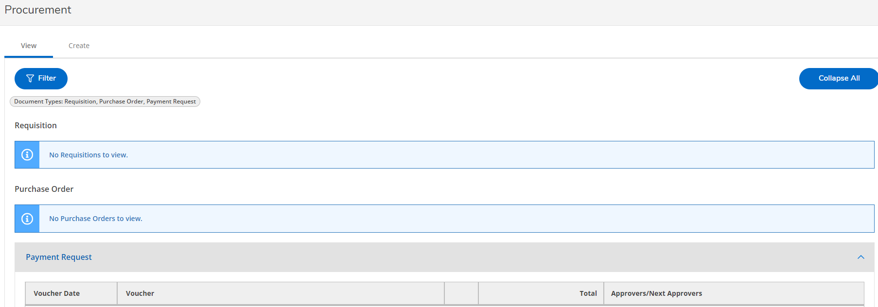

The Voucher you just entered will appear under the Payment Request section and will have Not Approved in a box next to it to show that it is waiting for approval by you and the next approver. Note that “Not Approved” is Self-Service’s wording, it really means “Not Approved Yet” since the request is waiting for approvers in the chain to act.
To approve your payment request
- In Self-Service
  - Go to Daily Work
  - Financial Management
  - Approve Documents
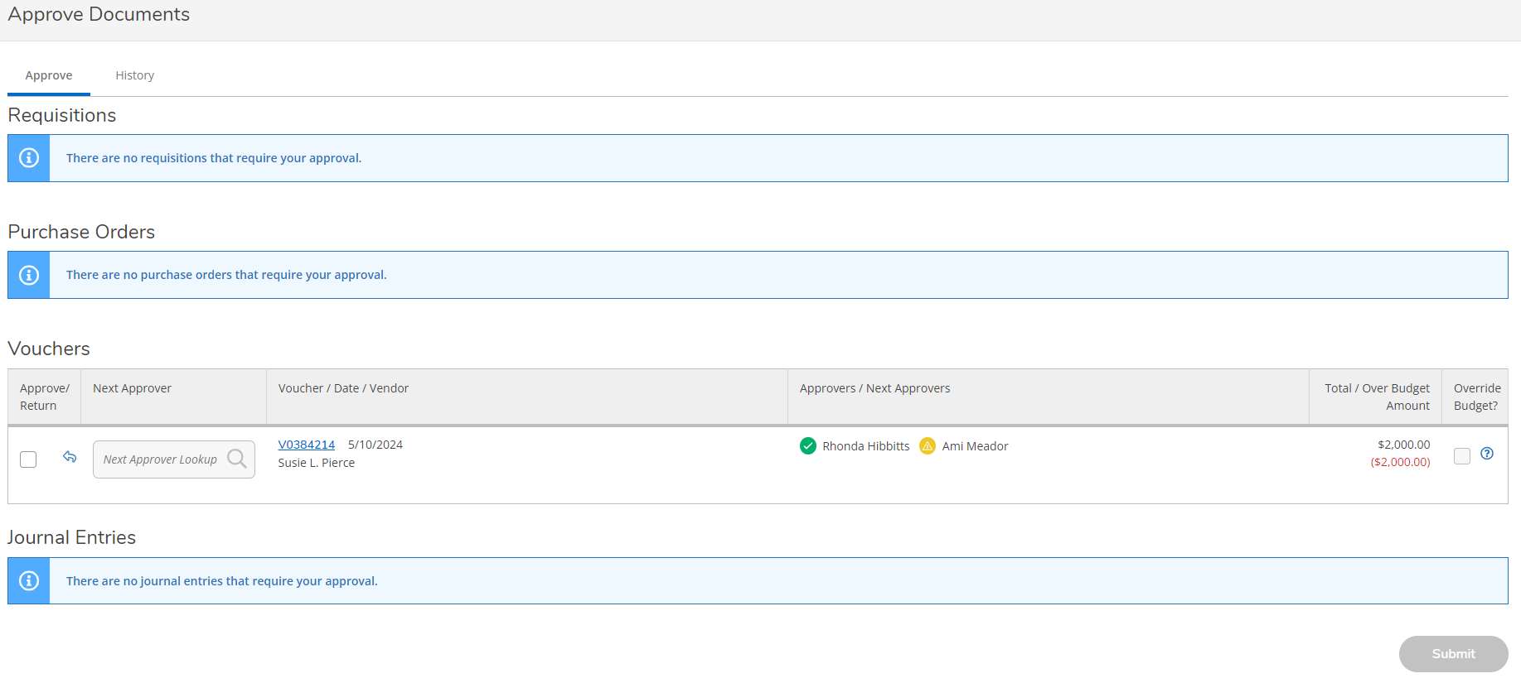
- It should come up on the Approve tab
  - When you have something to approve
  - It will show up below the Voucher heading
  - If you would like to view the voucher click on the number. It will pop up to the right of the screen.
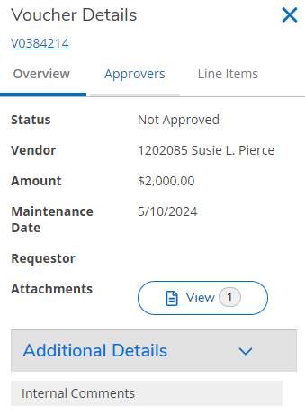
  - From here you can check to make sure there is an attachment included, the other approvers listed on the voucher and you can view the line items to review them.
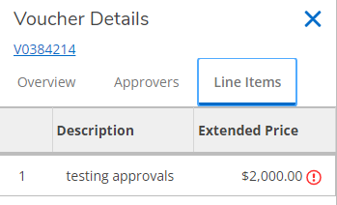
    - Click on the line you want to view
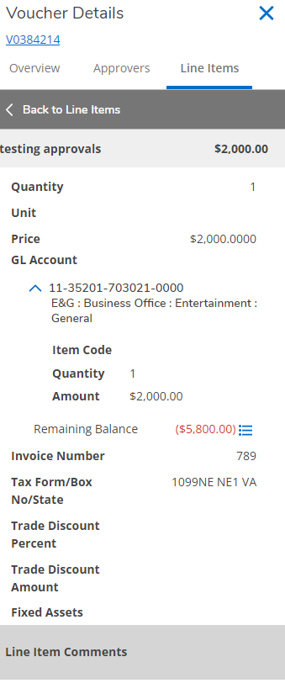
      - Verify that the account code/s is/are correct and the amount is correct
      - If you are over budget that will show in red like the example above
      - You can click on the three blue lines to view that budget line
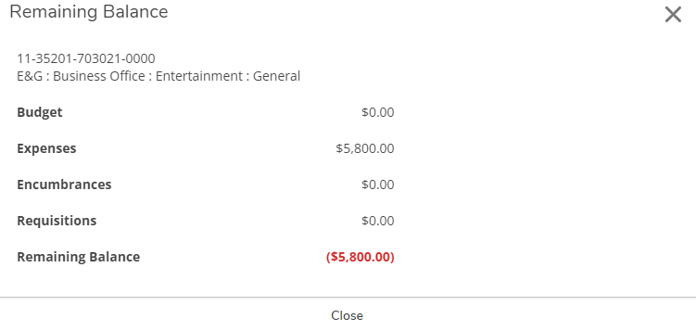
  - Once you verify that everything looks good you can approve the request by clicking in the box next to the voucher
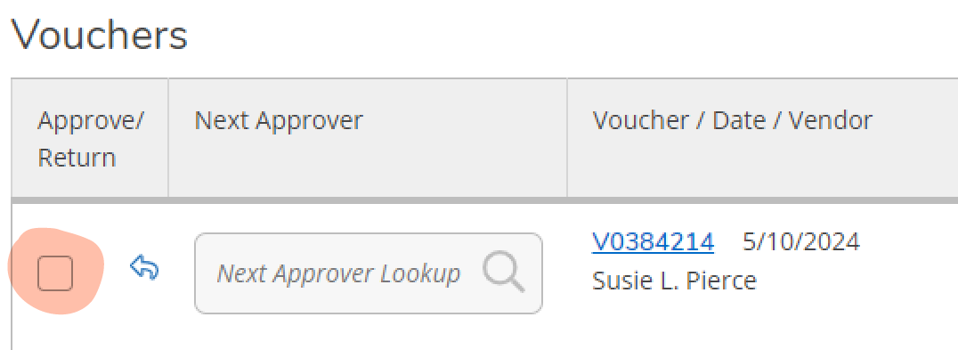
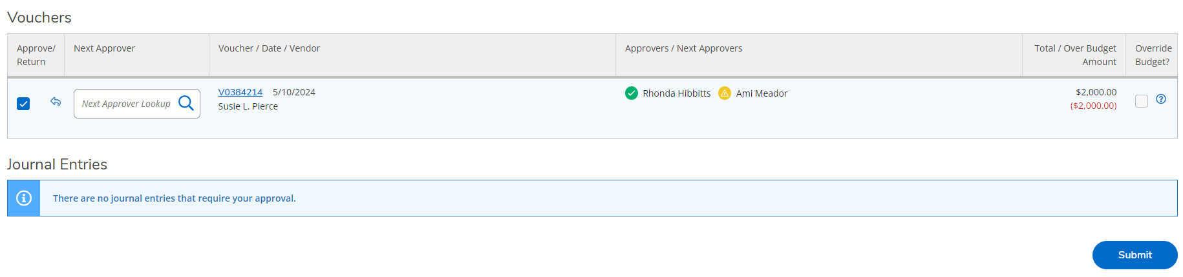
    - You may also add an additional approver once you click in the approve box if someone else needs to approve the voucher and you did not previously include them.
    - Then click on the blue Submit button at the bottom of the page.
      - You may click in multiple boxes to approve several at one time as long as you have reviewed all of the ones you selected. And then click the Submit button to submit them all as approved.
  - If there is something wrong with the voucher you will need to return to the Procurement screen and follow the steps listed above to edit it.
  - You can ignore the Override Budget? boxes, we are not using that function at this time.
- Next to the Approval tab you will find the History tab. Here you will see all of the vouchers you have approved.
  - You can filter these results by several variables to find what you are looking for.
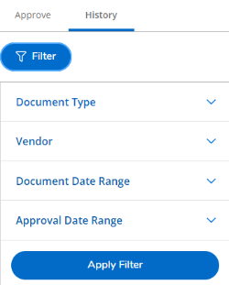

Once you and the second approver approved the voucher it will say Outstanding.
If you have voided your voucher it will have Voided next to it.
If the second approver returns the voucher to you it will have Returned next to it.
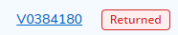
If a voucher has been returned to you there are notes that you can view in the notification email that you will receive to give you the reason put in by the approver that returned it to you.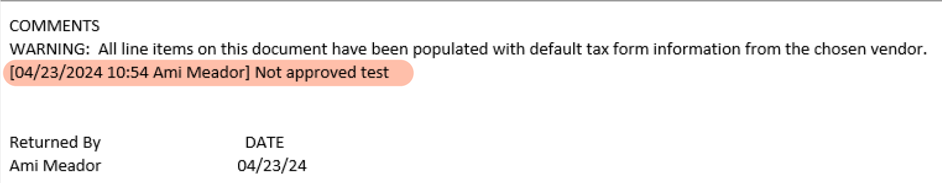
Once a voucher is paid it will have Paid next to it.
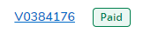
Once paid you will be able to view the check number and date. Just click on the voucher and it will pop up to the right. Click on Additional Details to expand that section and you will see that information there.
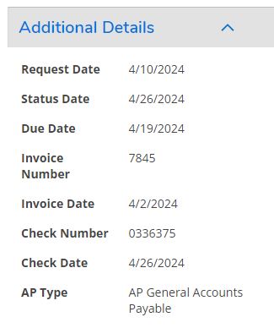
Once the check is reconciled you will see the Paid change to Reconciled next to the voucher number. This indicates that the check has cleared the bank.
Weekly to Dos:
Make sure to check your Procurement View tab at least weekly to make sure your requests have been approved and are progressing through the payment process listed previously.

***** If the Business Office finds a problem with your attachments, for example missing signatures or receipts, a comment will be put on the voucher to let you know what the problem is. You will be able to see this on the comment section of the voucher as shown below. If there is a problem you will need to go in and correct the issue before payment will be made on that voucher. *****

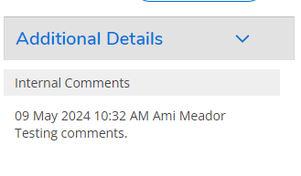
Be sure to include all needed attachments to your payment request.
Examples include:
- Travel Expense Form with both signatures and all supporting documents
- Receipts with method of payment and detail of what was purchased
- Invoice

