Voucher Approval Instructions

In Self-Service:
Go to Daily Work
Financial Management
Approve Documents
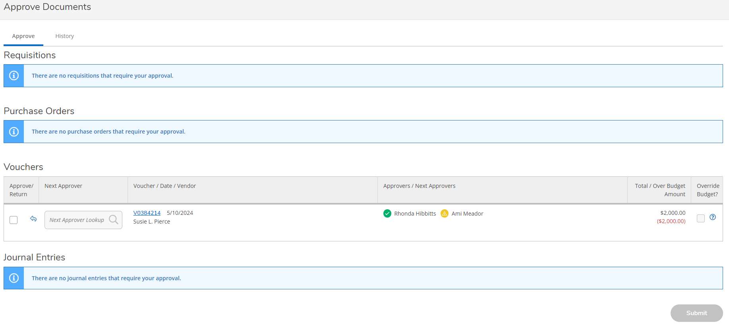
It should come up on the Approve tab
When you have something to approve:
It will show up below the Voucher heading
- Click on the voucher to view it. It will pop up to the right of the screen.
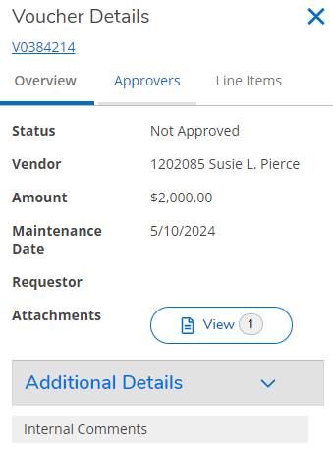
  - Make sure to check the attachment to see if it is the correct one for the voucher and verify that all needed documents for backup are included.
  - Internal Comments are for notes on what the payment request is for and may be blank.
  - Click on the Line Items tab:
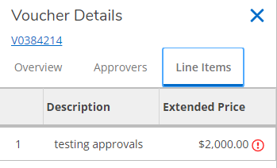
    - Click on the line you want to view
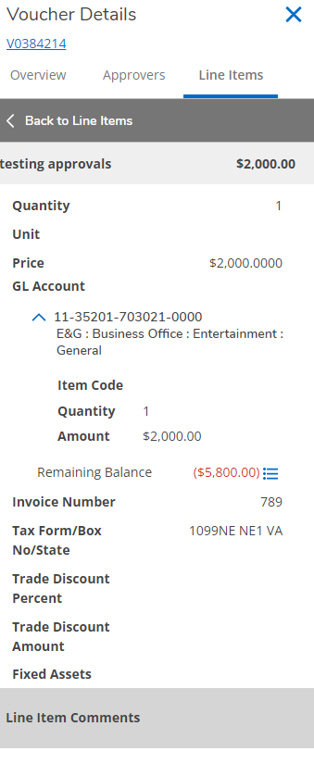
      - Verify that the account code/s is/are correct and the amount is correct
      - If you are over budget that will show in red like the example above
      - You can click on the three blue lines to view that budget line
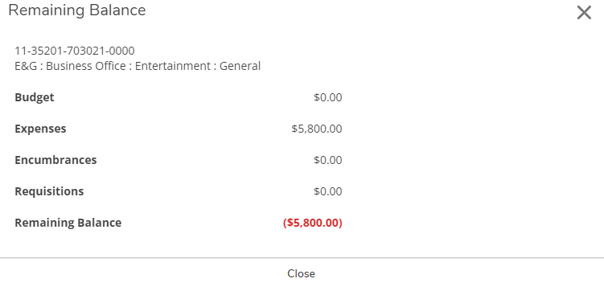
  - Once you verify that everything looks good you can approve the request by clicking in the box next to the voucher
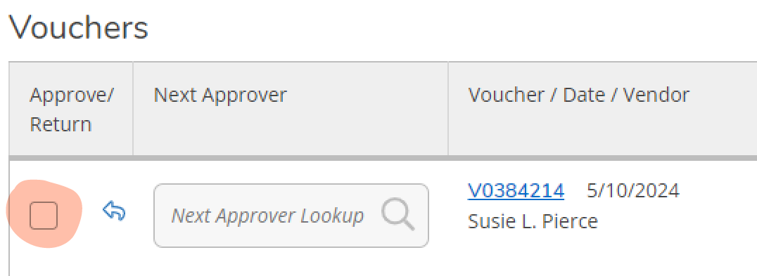
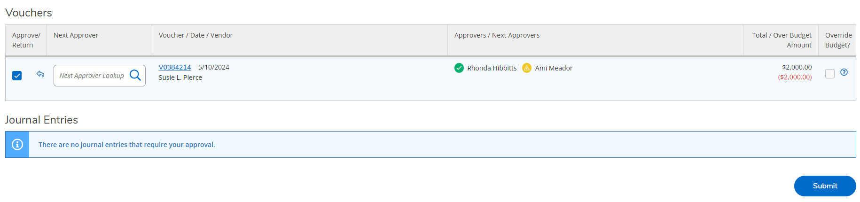
    - You may also add an additional approver once you click in the approve box if someone else needs to approve the voucher.
    - Then click on the blue Submit button at the bottom of the page.
      - You may click in multiple boxes to approve several at one time as long as you have reviewed all of the ones you selected. And then click the Submit button to submit them all as approved.
  - If there is something wrong with the voucher click on the return arrow to return it to the requestor.
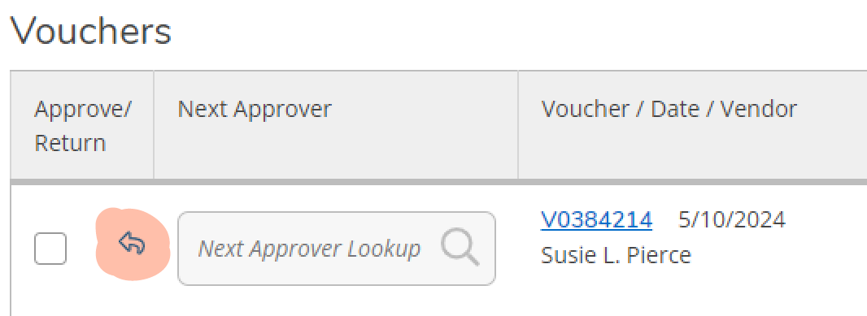
    - Put in notes to let them know why it is being returned
      - For example: Missing receipts or missing signatures on a travel expense form
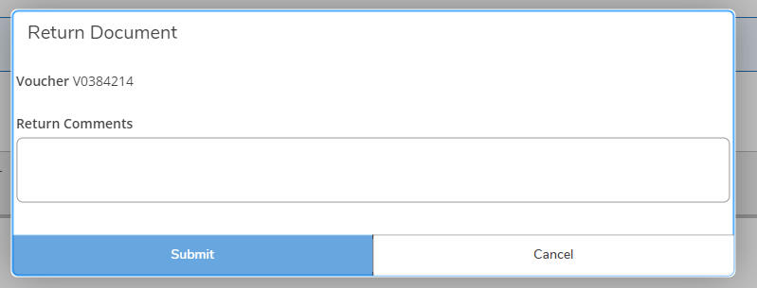
      - Click submit once you are done typing the comments.
  - You can ignore the Override Budget? boxes, we are not using that function at this time.
- Next to the Approval tab you will find the History tab. Here you will see all of the vouchers you have approved or returned.
  - You can filter these results by several variables to find what you are looking for.
